COURSE 1 → WEEK 2 NOTES.

Topic 1.6 of the book.
Visualizing the Numeric data:

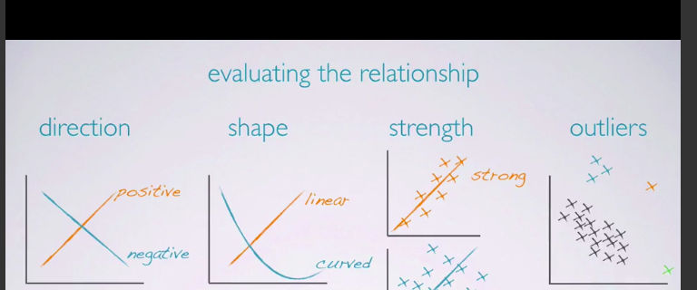
histogram helps us to determine the dist of the data, it provides a view of data density.

Skewness : dists are skewed to the side of the long tail.

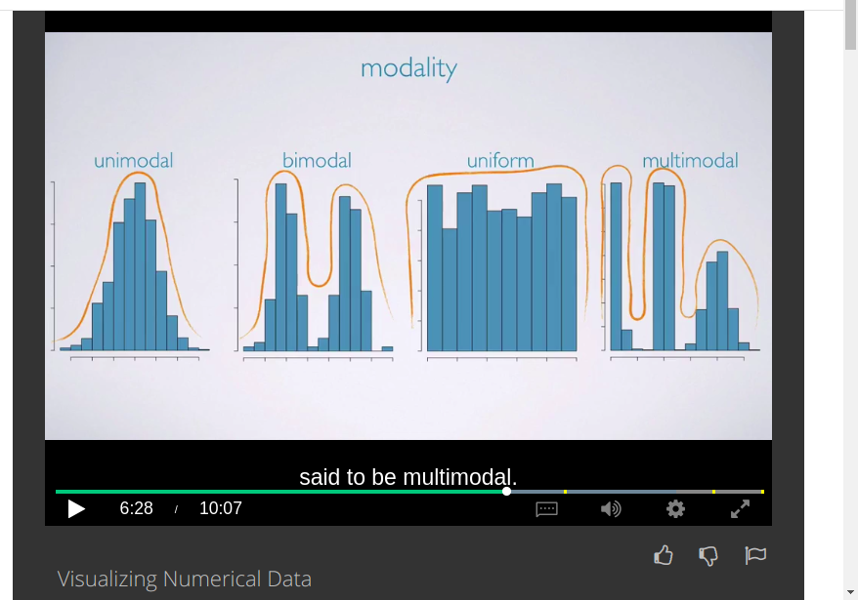
The bimodal shows that there are 2 groups in a data set while uniform shows that there’s no trend every value in a data is equally likely to occur.

While symmetric shows that most of the readings/values in a data set are around the mean.
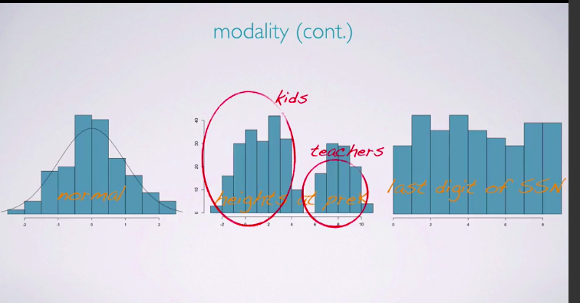
Here the last graph of the above pic is the plot of the last digit of Social security number of US citizen ,which is a Uniform dist as expected.

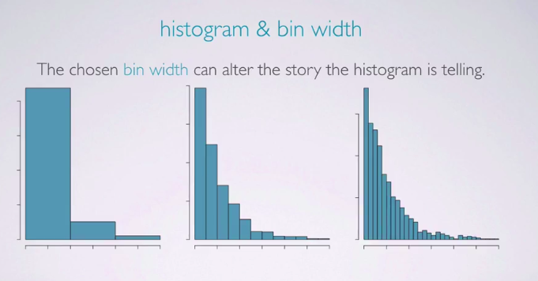
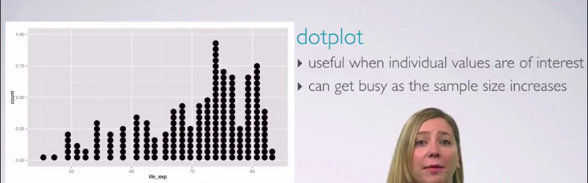

BOX PLOTS: useful for highlighting outliers and IQR.(inter quartile range):

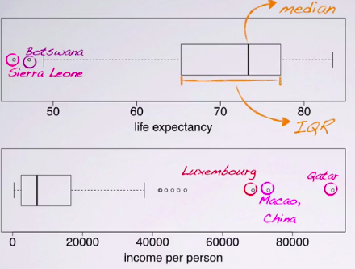
they donot show the modality, but they do show skewness.

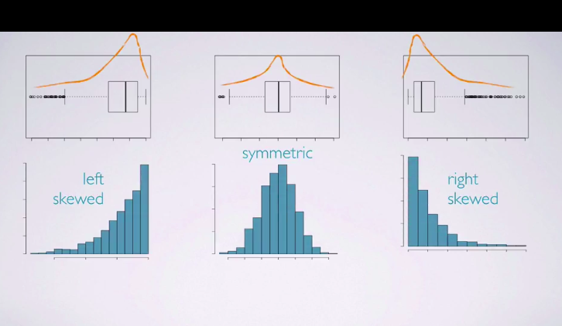

INTENSITY MAP:

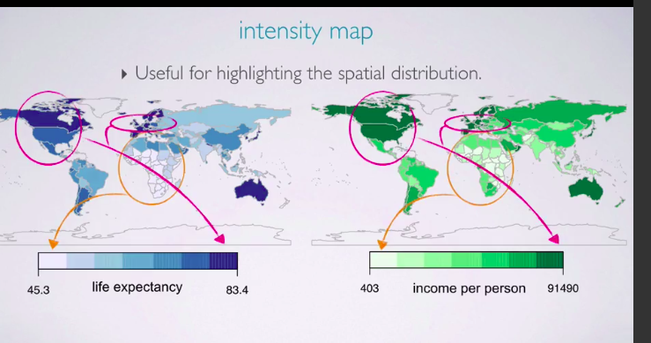
MEASURE OF CENTER:
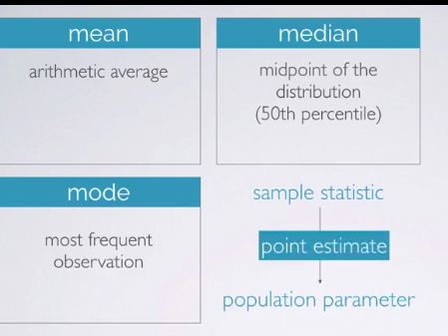
Another key characteristic that is of interest is the center of the distribution, commonly used measures of center are the mean, which is simply the arithmetic average. The median, which is the mid point of the distribution or in other words the 50th percentile and the mode which is the most frequent observation. If these measurements are calculated from a sample, they're called sample statistics. Sample statistics are point estimates for the unknown population parameters.

We usually use letters from the Latin alphabet when denoting sample statistics, and letters from the Greek alphabet when denoting population parameters. For example, the sample mean is x bar and the population mean is mu.
Which statement is true:

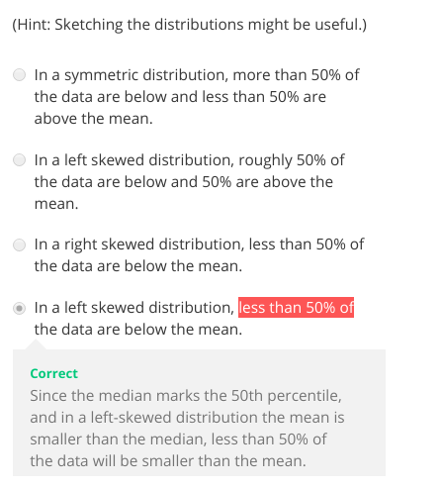

less than 50 is noticable.

Measure of spreads:

range,variance,std and IQR.

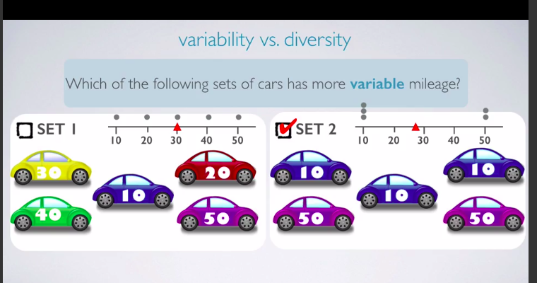
The set 1 is more diverse but the set 2 is more variable bcz the means are 30 and 26 which is roughly equal but the values aren’t centered in the set 2 they are at end points.

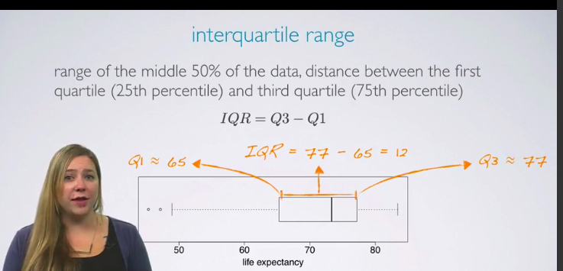

Robust statistics:

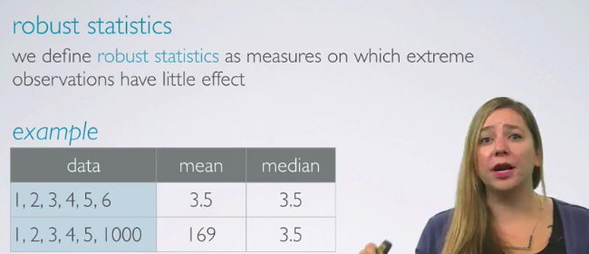

median is more robust then the mean because it doesn’t relies on the extreme values.

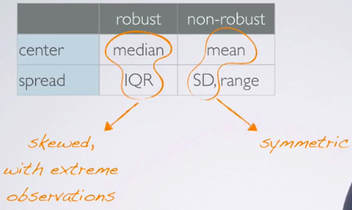

Robusts are used for skewed distributions while we use mean and std for symmetric.

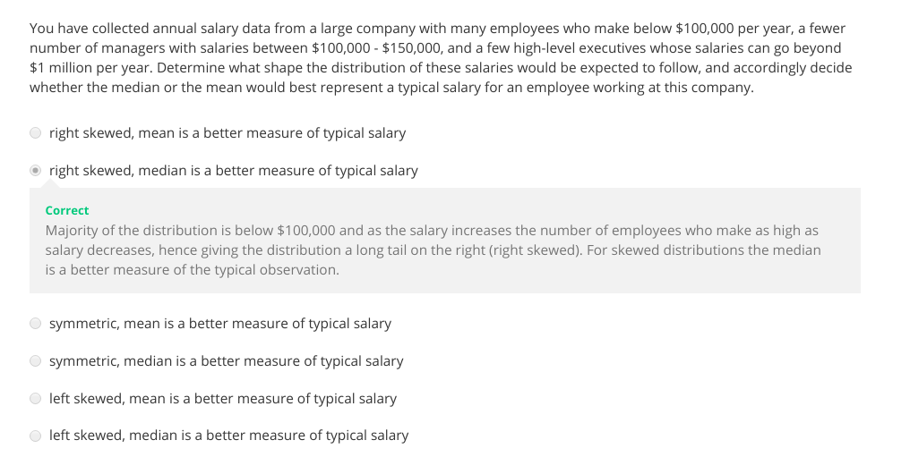

TRANSFORMING DATA:

Goals of transforming the data:

We might want to see the data structure a little differently.
We might want to reduce skew to assist in modeling
We might want to straighten a nonlinear relationship in a scatterplot, so that we can model the relationship with simpler methods.

CATEGORICAL VARIABLES:

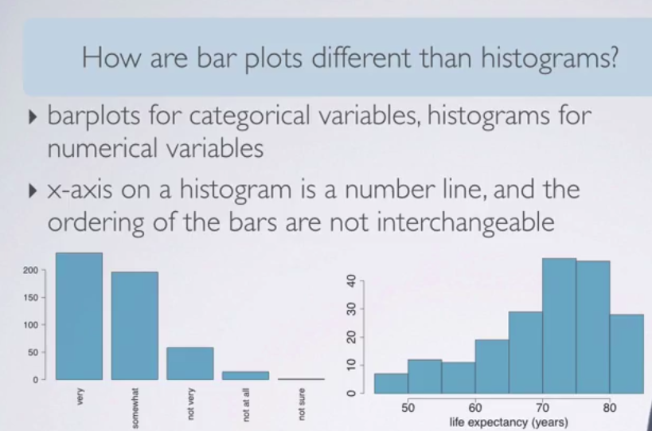

This video is must for exploring categorical variables.

For single categorical variable we use frequency distribution table while for more than 2 categorical variable we use contingency table.

We use segmented barplot for contingency table.

STATISTICAL INFERENCE:

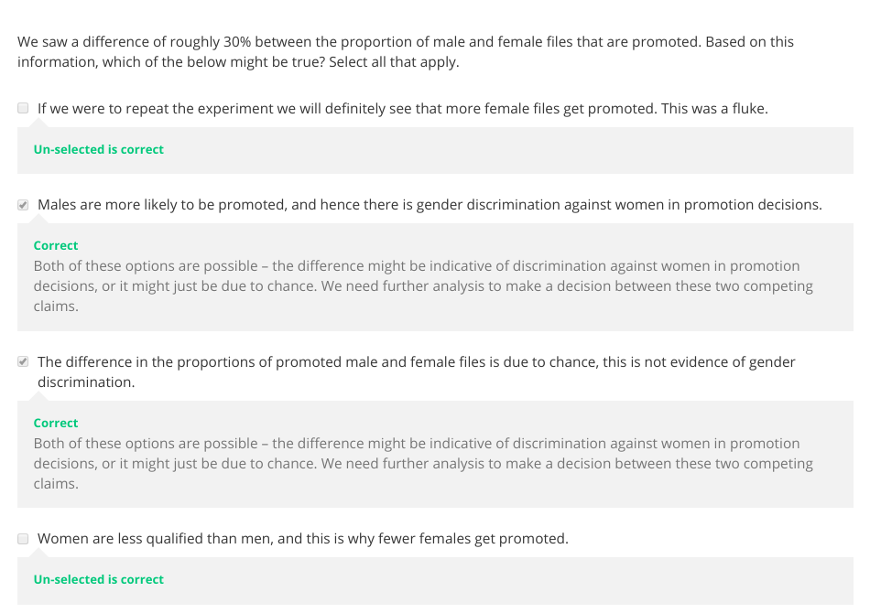

if the null hypothesis is true than the Z statistic has a std normal distribution

Z-scores can be calculated for distributions that are not normal.

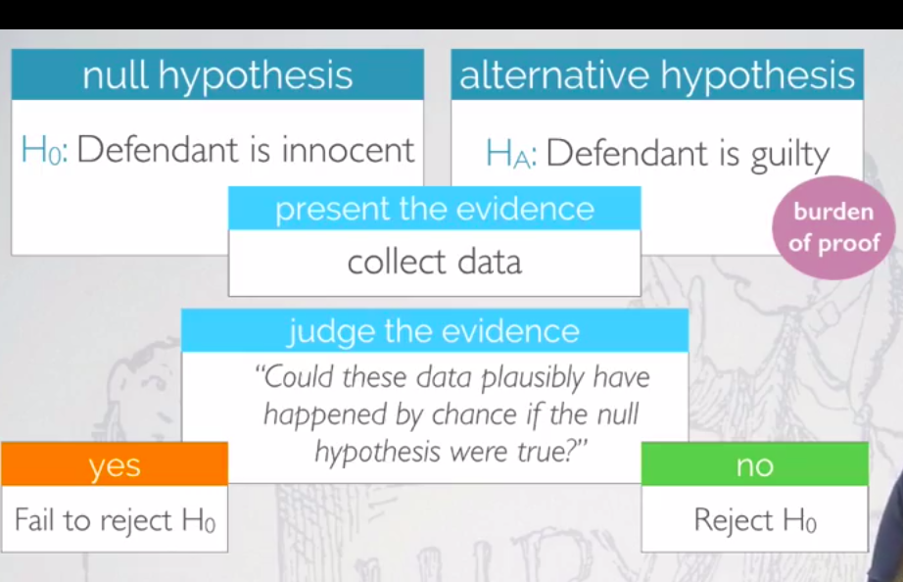

Hypothesis testing is very much like a court trial in the US. The null hypothesis says that the defendant is innocent and the alternative hypothesis says that the defendant is guilty. We then present evidence or, or in other words, collect data. Then, we judge this evidence and ask ourselves the question, could these data plausibly have happened by chance if the null hypothesis were true?

If the data were likely to have occurred under the assumption that the null hypothesis were true, then we would fail to reject the null hypothesis, and state that the evidence is not sufficient to suggest that the defendant is guilty. Note that when this happens, the jury returns with a verdict of not guilty. The jury does not say the defendant is innocent, just that there is not enough evidence to convict. The defendant may in fact be innocent but the jury has no way of being sure. Said statistically, we fail to reject the null hypothesis. We never declare the null hypothesis to be true. Because we do not know and cannot prove whether it's true or not. Therefore, we also never say that we would accept the null hypothesis. If the data were very unlikely to have occurred, then the evidence raises more than a reasonable doubt in our minds about the null hypothesis, and hence we reject the null hypothesis
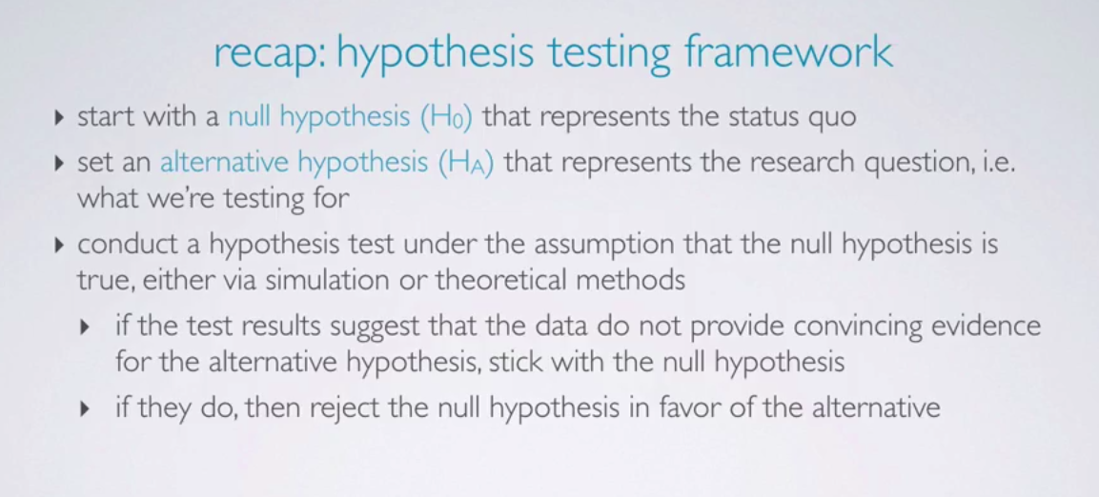
how to make decision?

Case study is the gender discrimination in promotion.
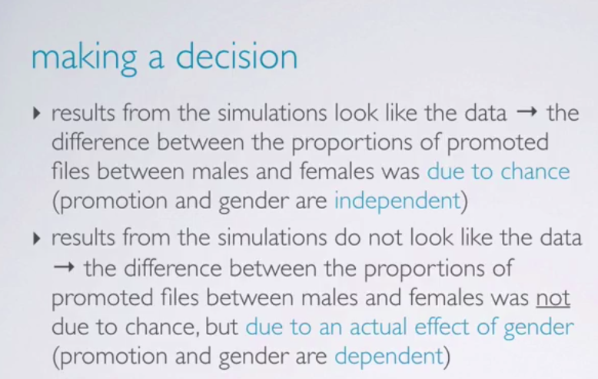
We simulated the experiment and obtained 100 samples I.e randomly assigning the files to the officers for promotion of males and females and we observed the diff between the proportions of them being promoted or not we then took the difference between their proportions and plot it using dot plot.
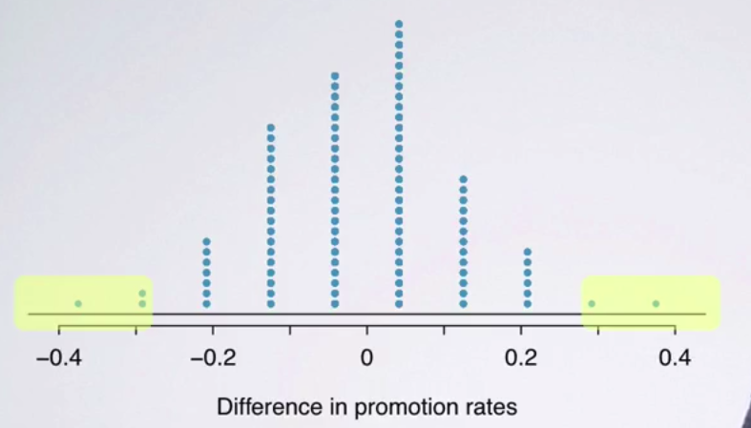
The plot shows that the promotion is independent of gender because the difference is highly centered around the zero. And there’s only 5% of the time when the difference between them is 30%.

therefore we reject our null hypothesis that the promotion is dependent on gender discrimination.

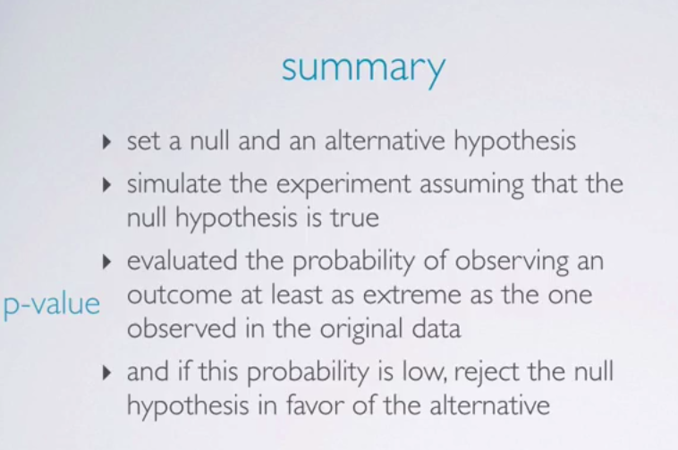

P-VALUE

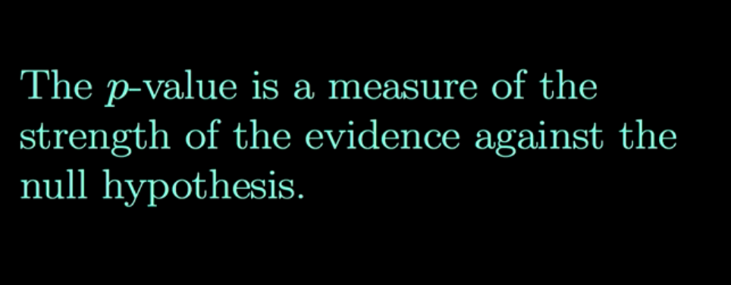

if the null hypothesis is true than the Z statistic has a std normal distribution

if p value is < alpha then we will reject the null hypothesis.

Week 3
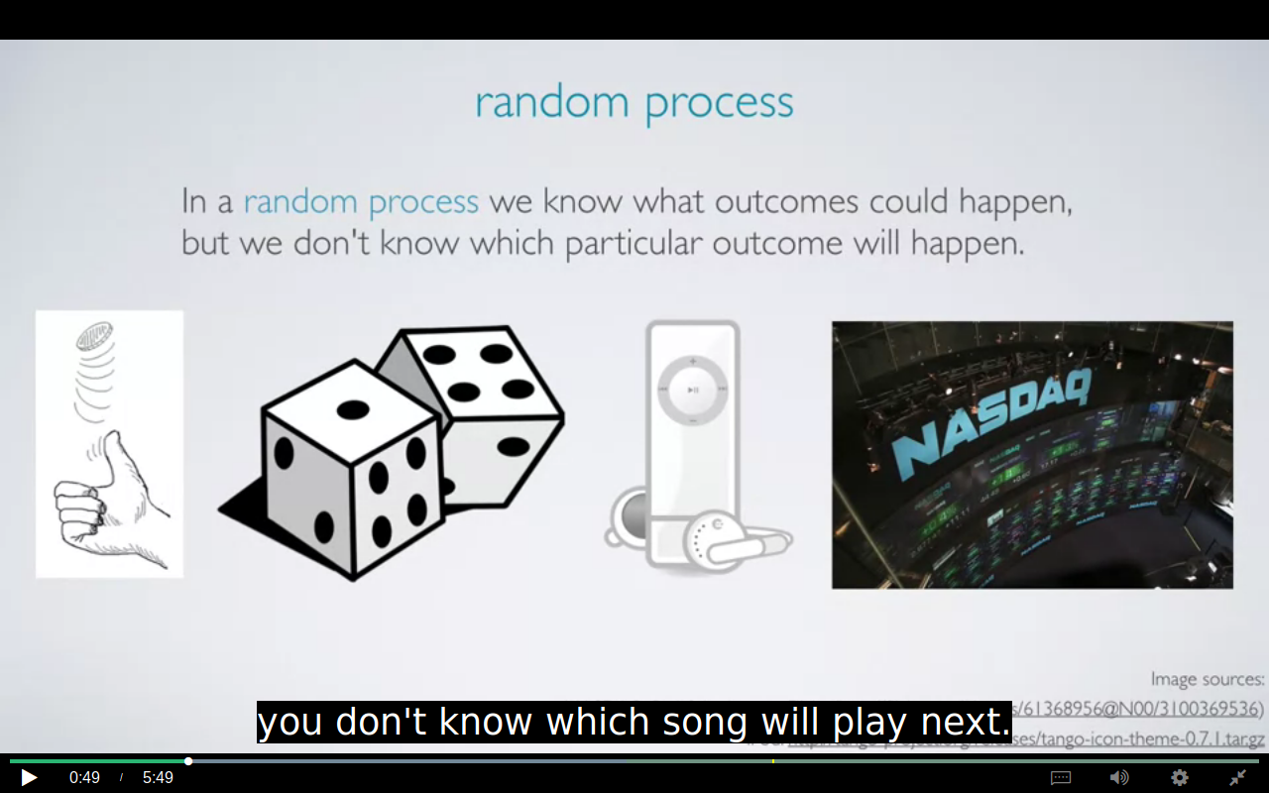

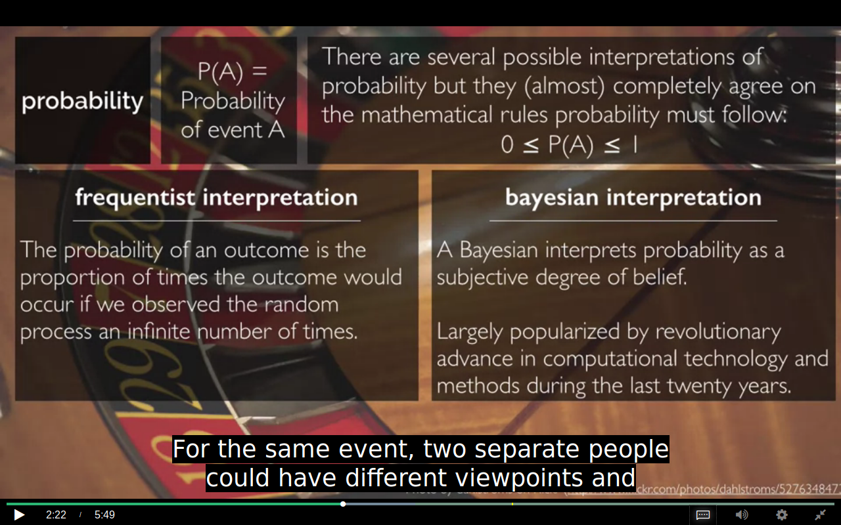
in bayesian interpretation 2 people can assign diff probability to the same event.
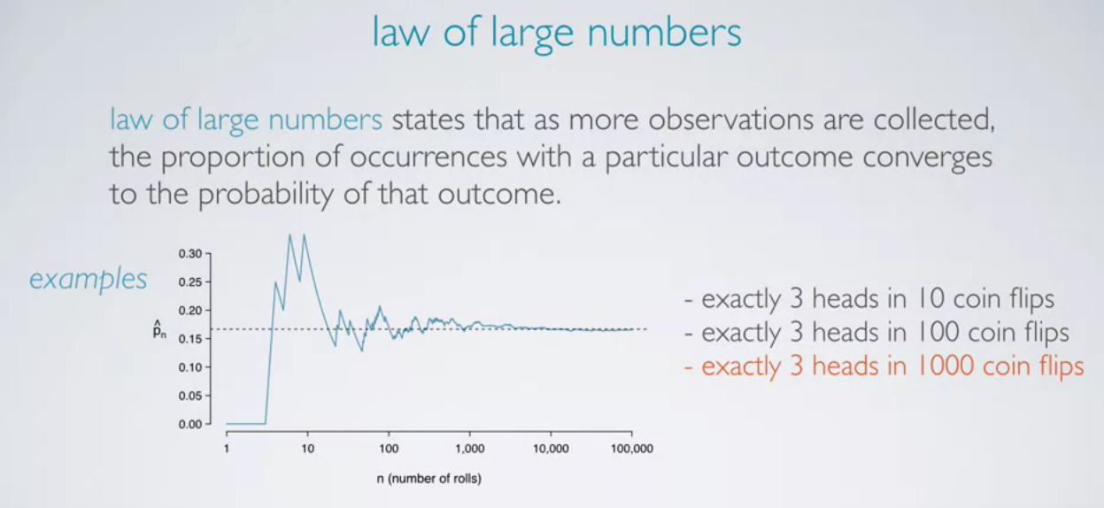

This is more unusual
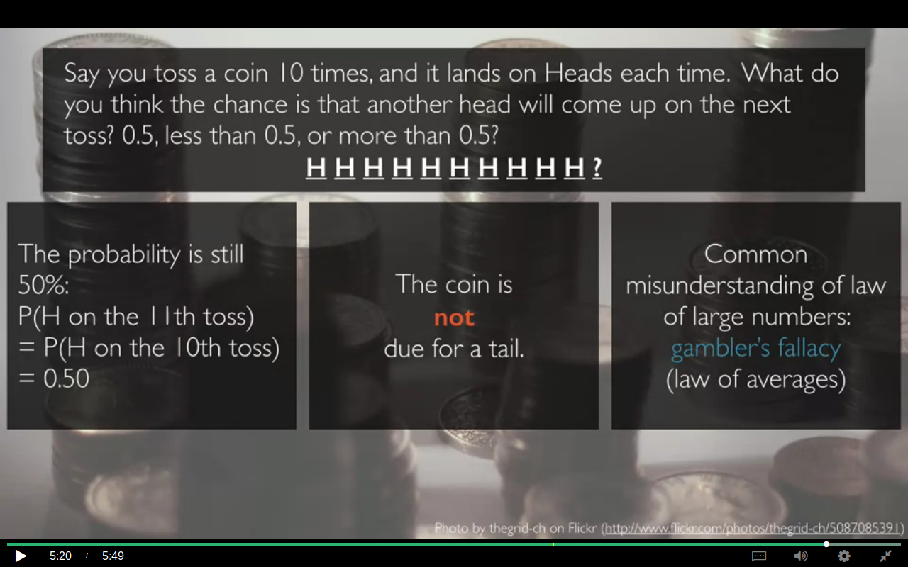
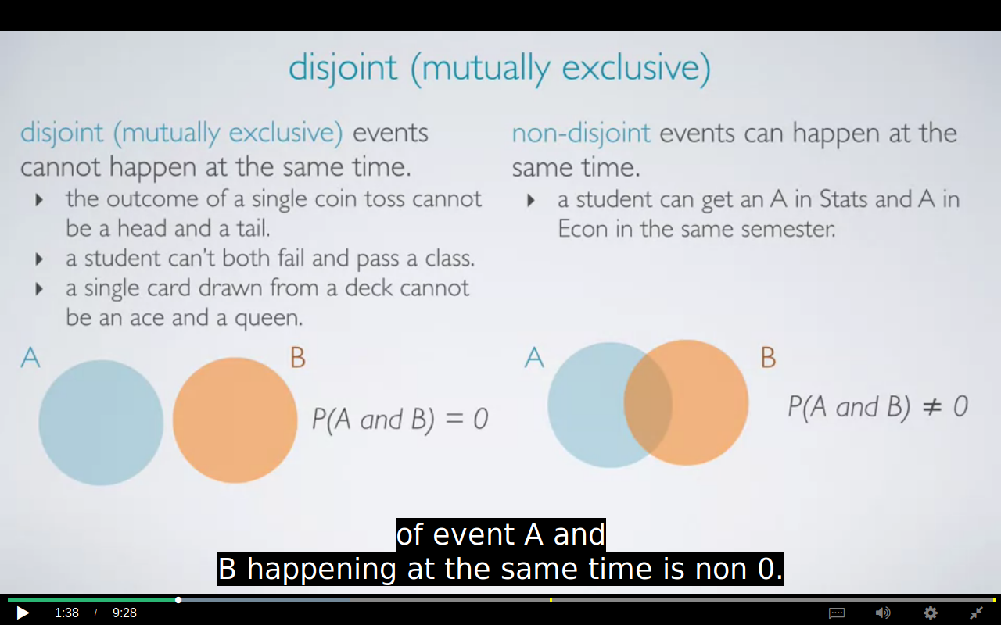

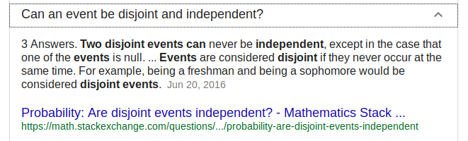

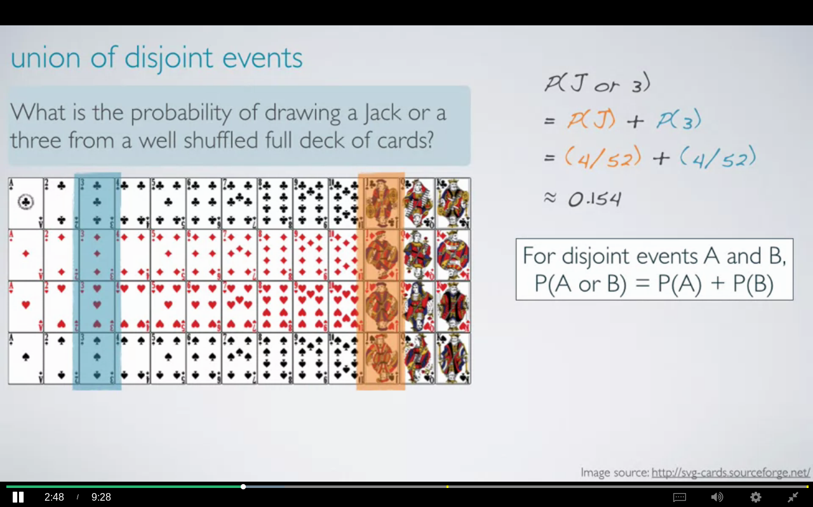

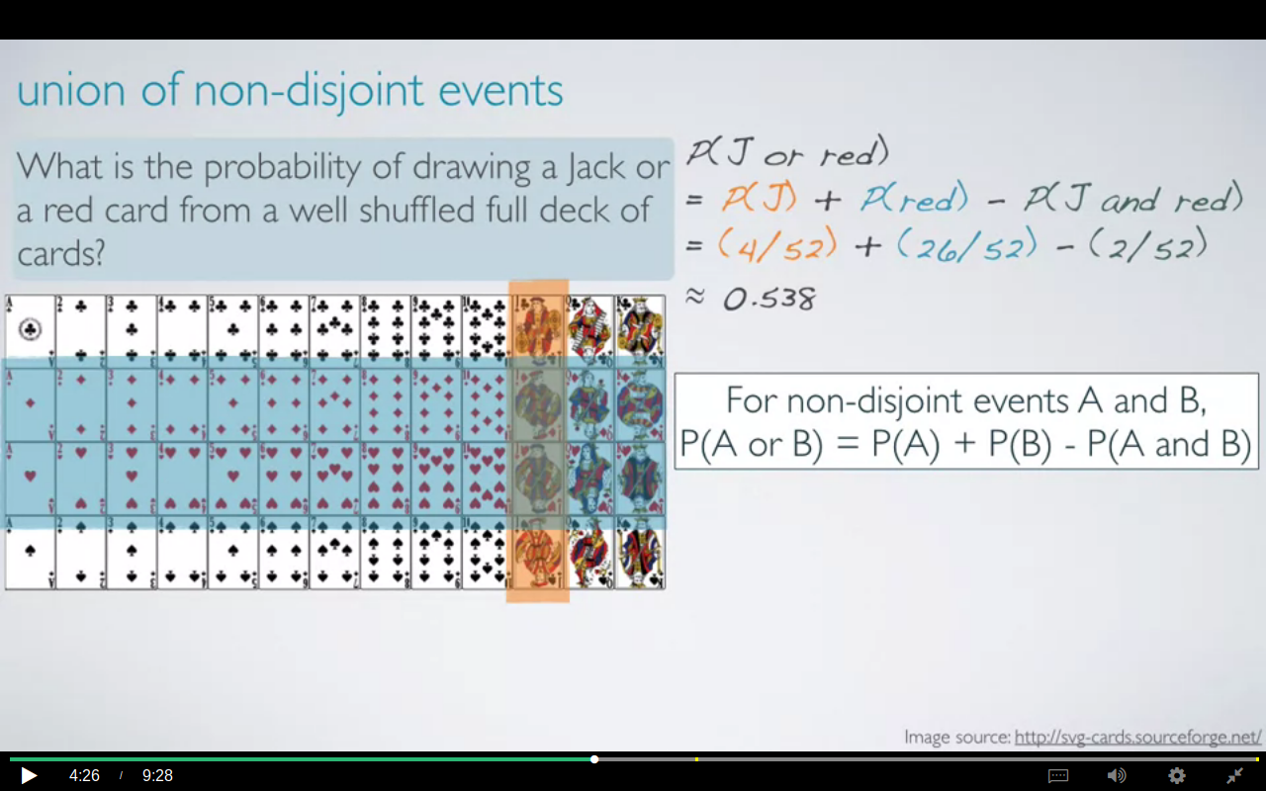

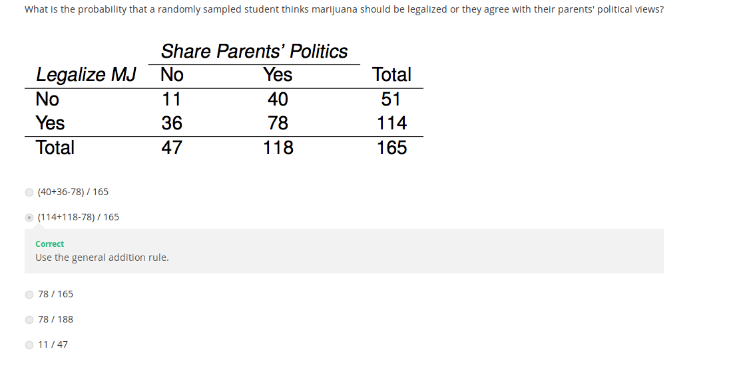
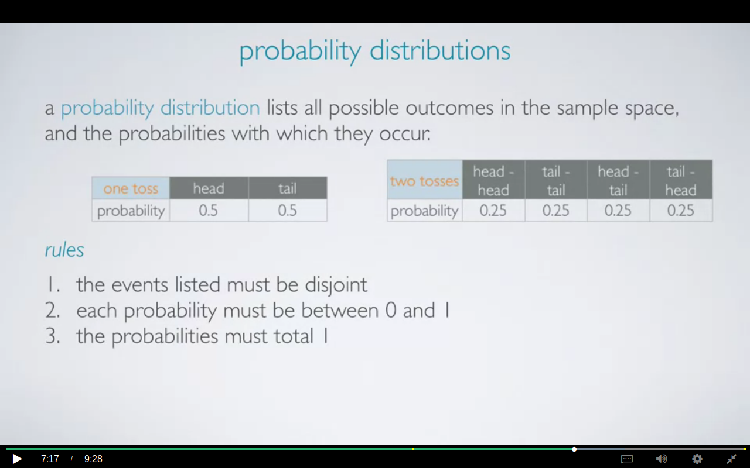

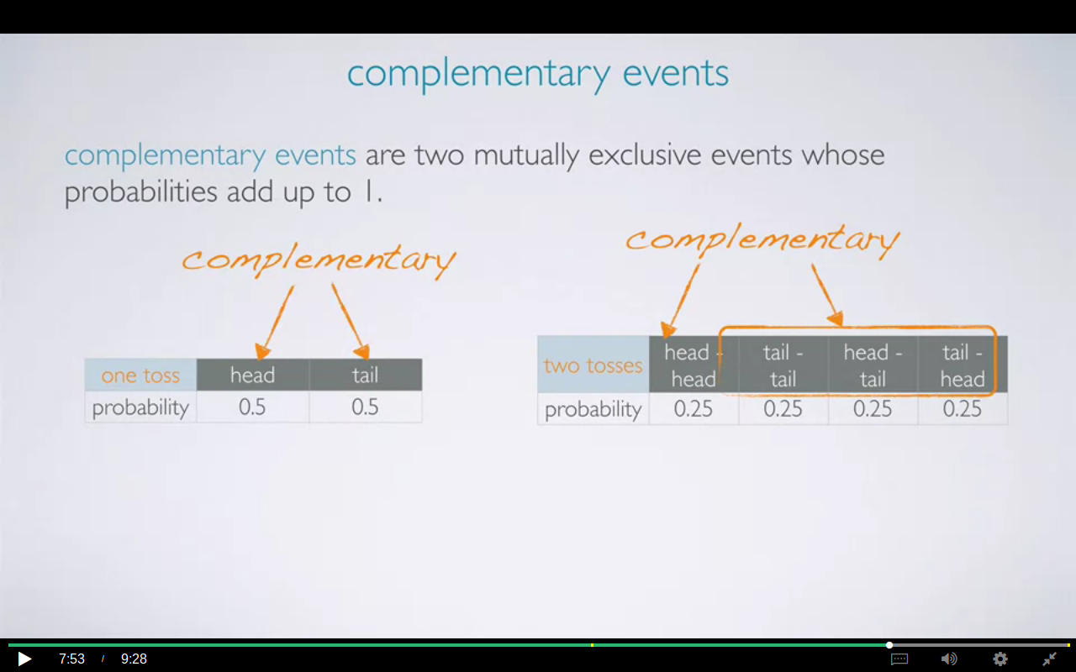
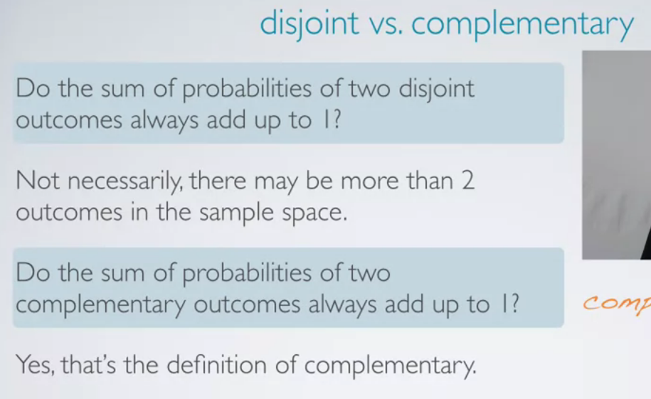
Complementary are always disjoints but disjoints aren’t always complementary.

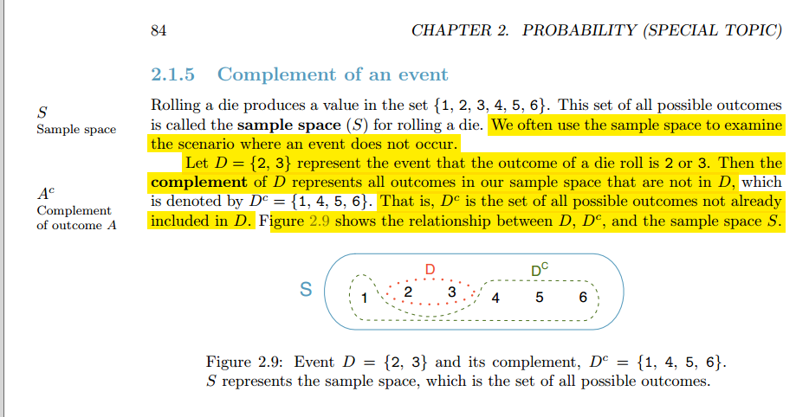
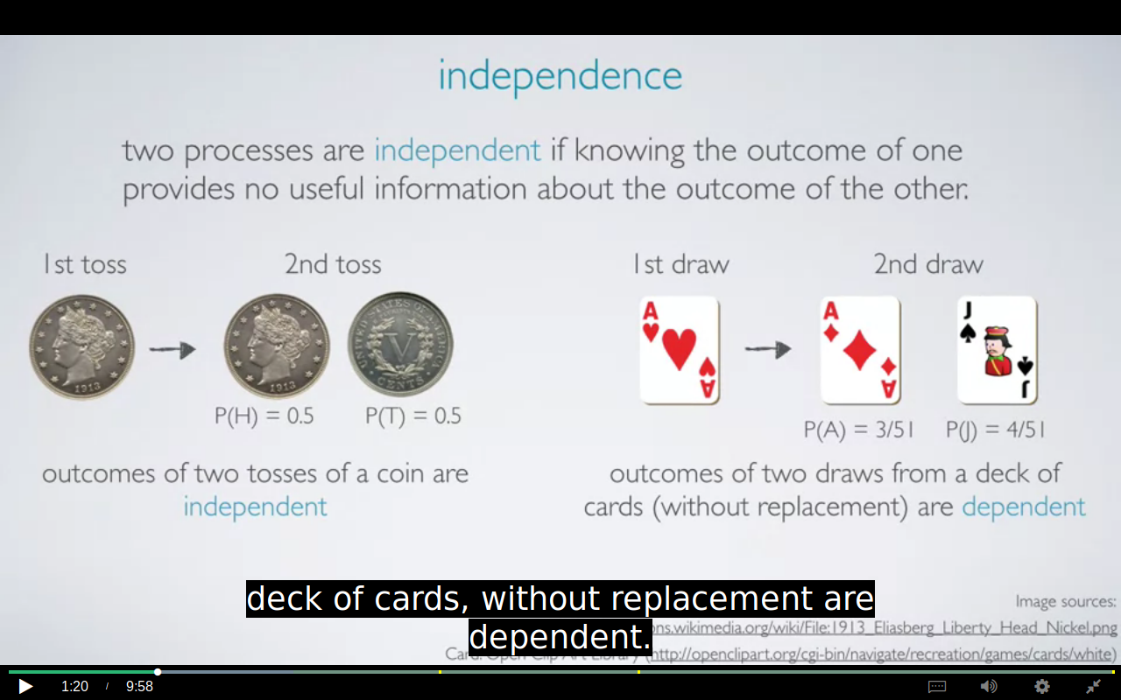

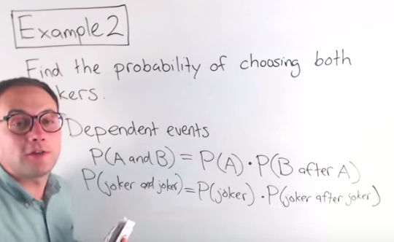

If the probability of an event A occurring, given that event B occurred
is the same as the probability of event A occurring in the first place, then events
A and B are said to be independent. (as in the case of coin tossing)
This rule basically says that knowing B tells us nothing about A
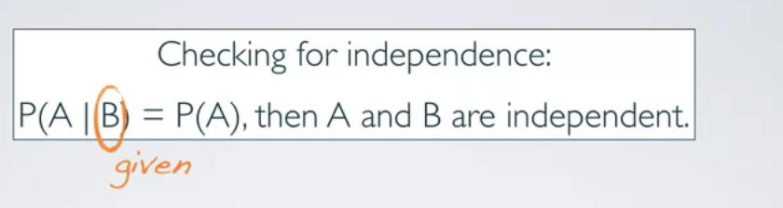

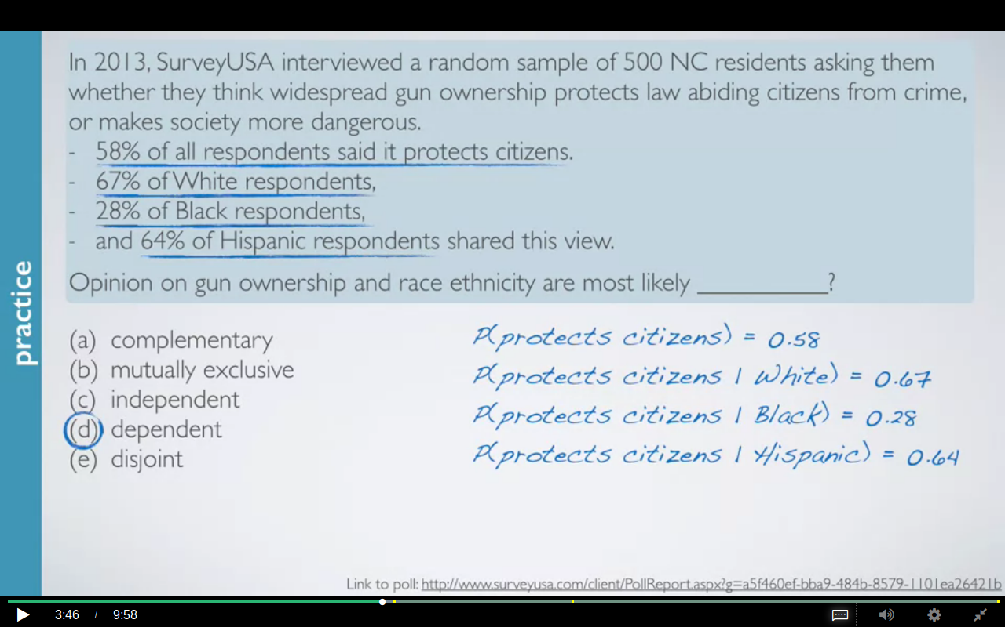
P(citizen who thinks that gun protects given that he is white ) is 0.67.

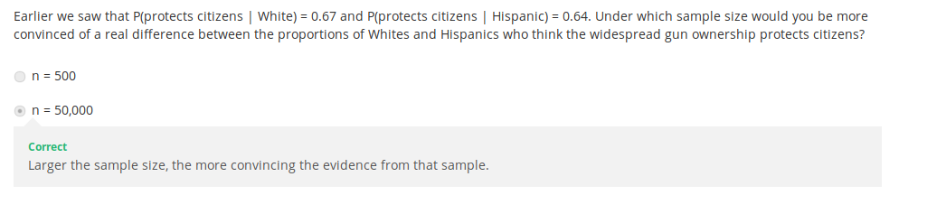

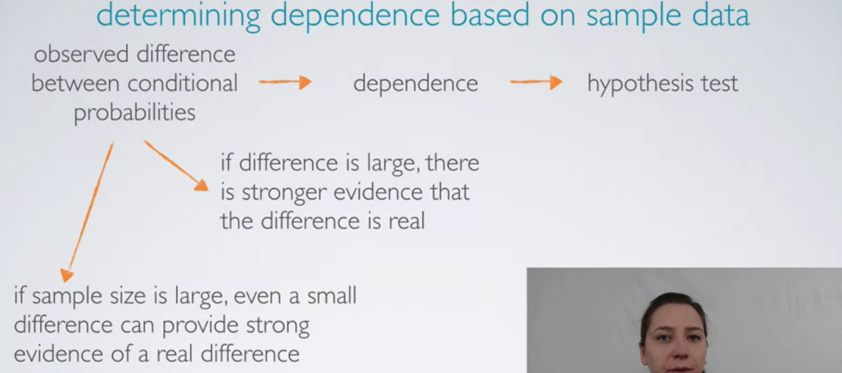
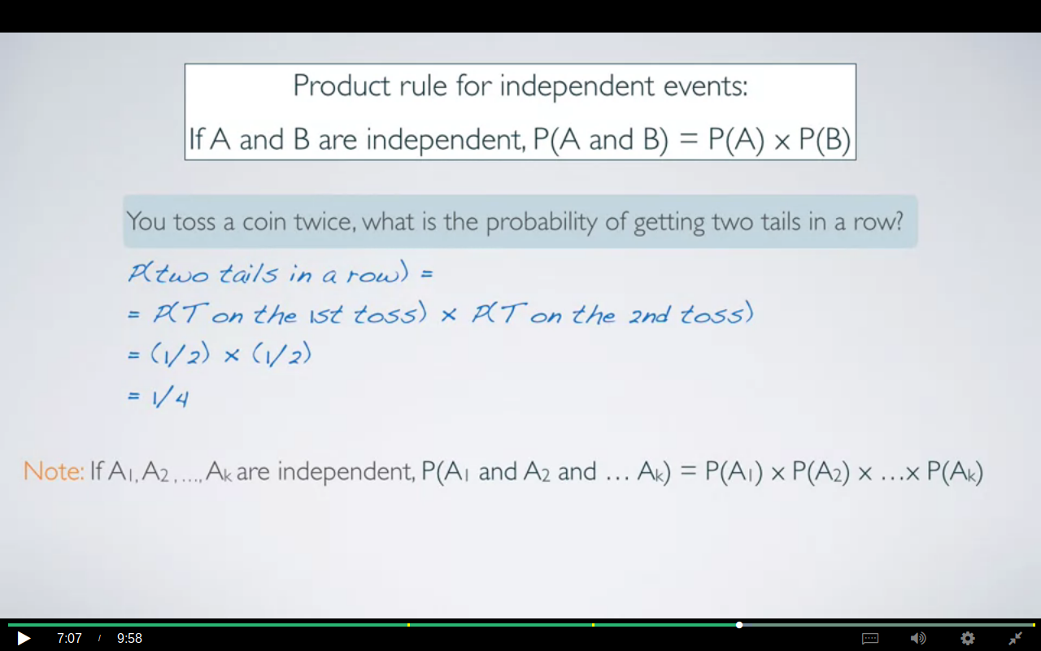

if A1, A2 all the way through Ak are independent, then probability of all of these events happening at once is simply going to be the product of the individual probabilities of the events

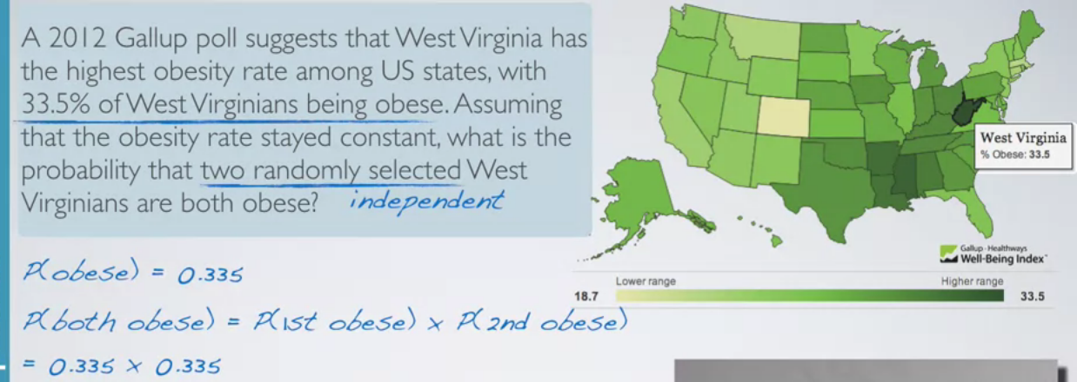

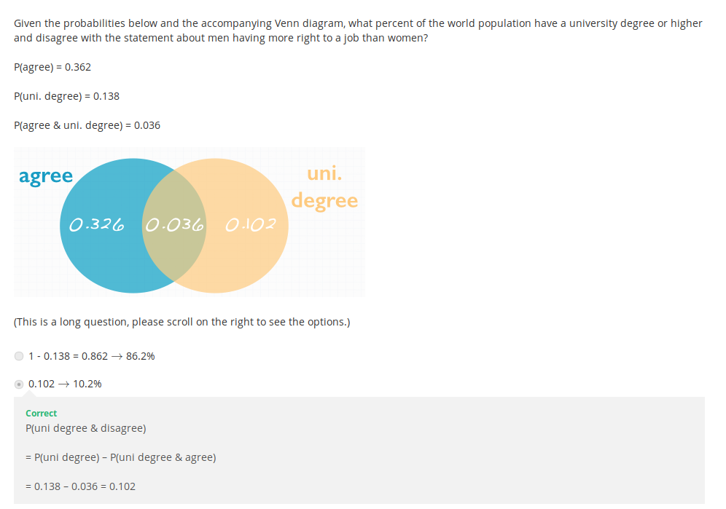

below are the 2 ways for calculating the probability by using addition rule and venn diagram.
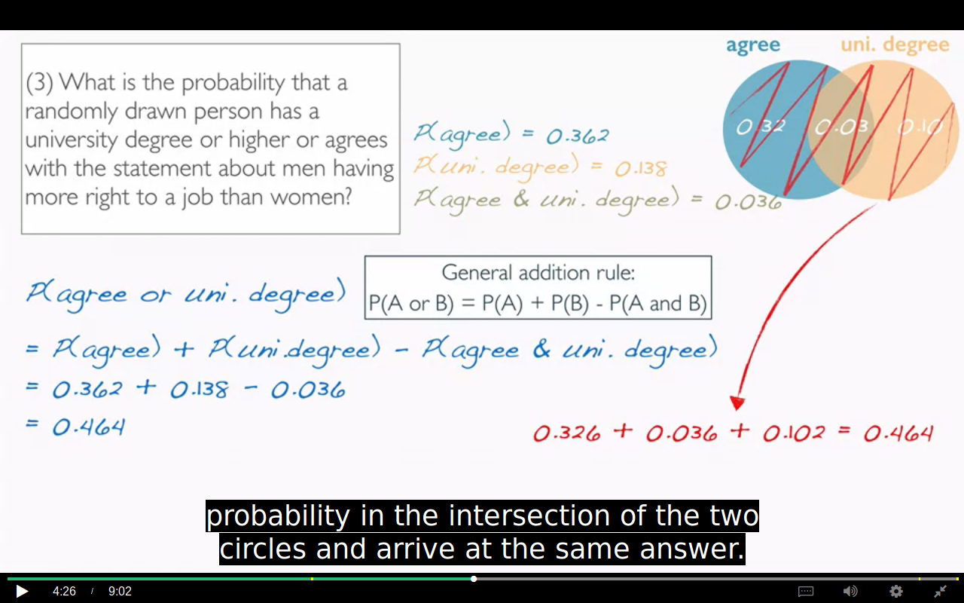
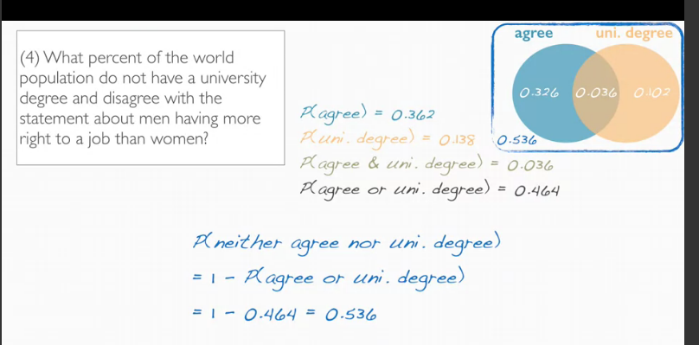

How to check independence ?
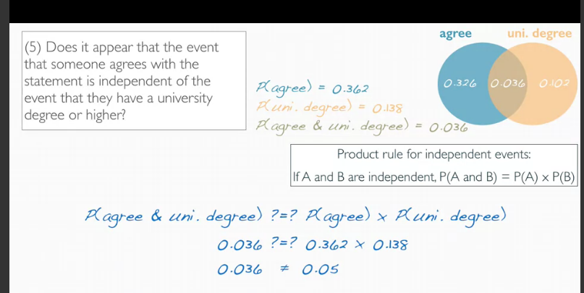
They aren’t independent as the occurrence of event doesn’t give us any hint about the occurrence of second event.
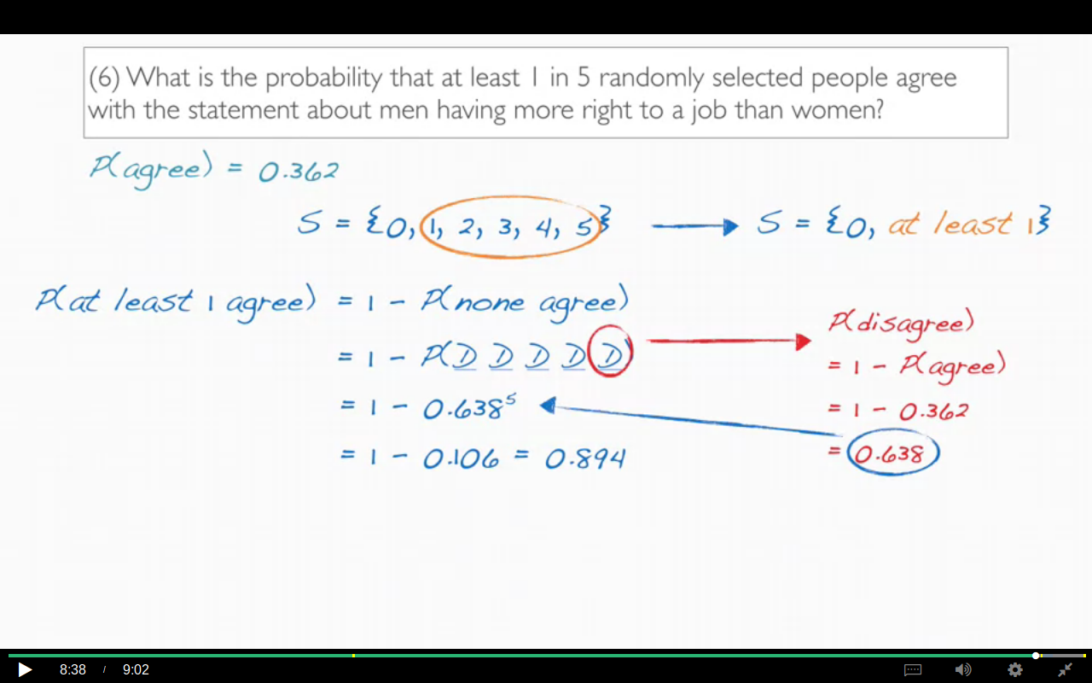

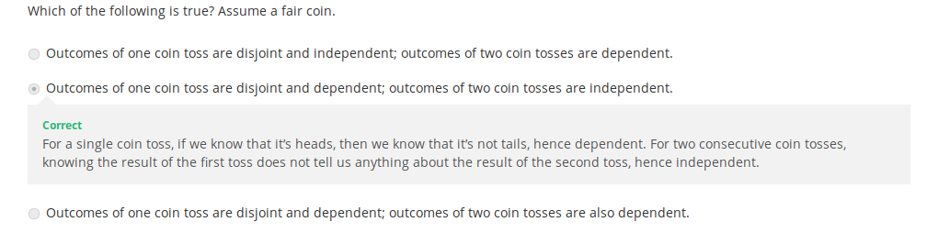
We can generalize this to say that disjoint events with non-zero probability are always dependent on each other. Because if we know that one happened, we know that the other one cannot happen.

Conditional probability

joint probability:
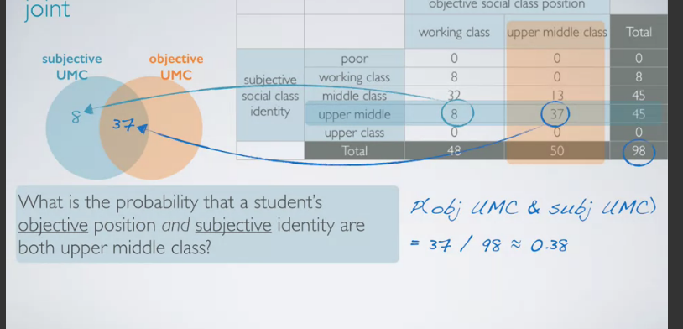
The term joint probability comes from the fact that we're considering the students who are at the intersection of the two events of interest.

CONDITIONAL :
read it from the book too.
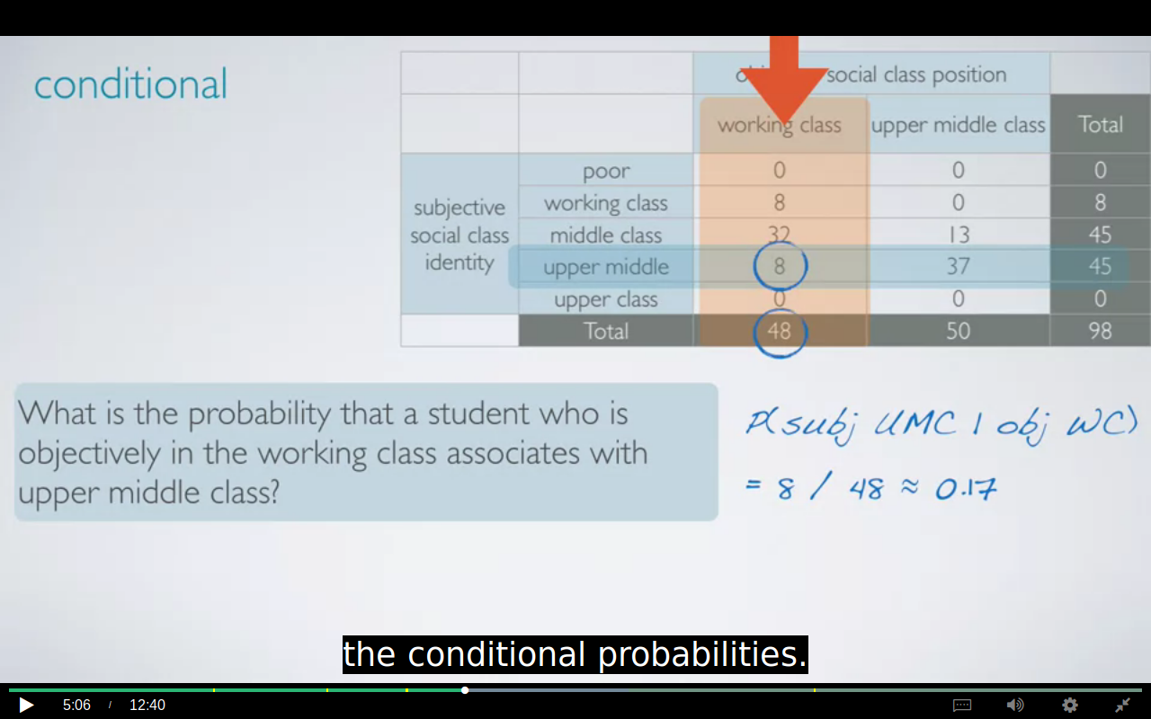

When the counts are not given we use bayes theorm to calculate the conditional probabilities.
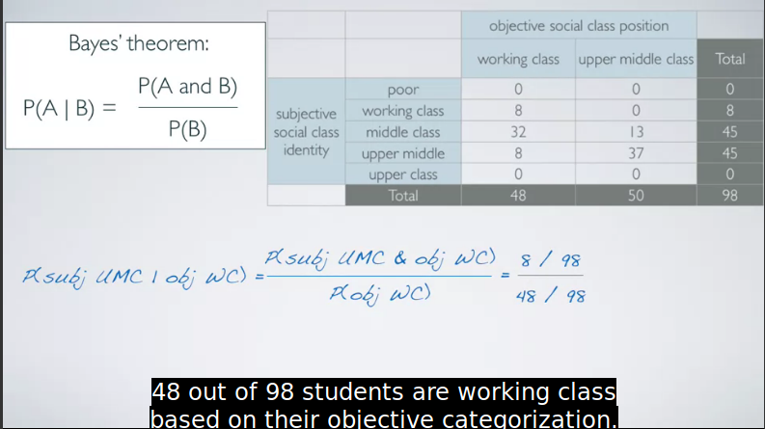
The numerator is the joint probability while the denominator is the marginal .

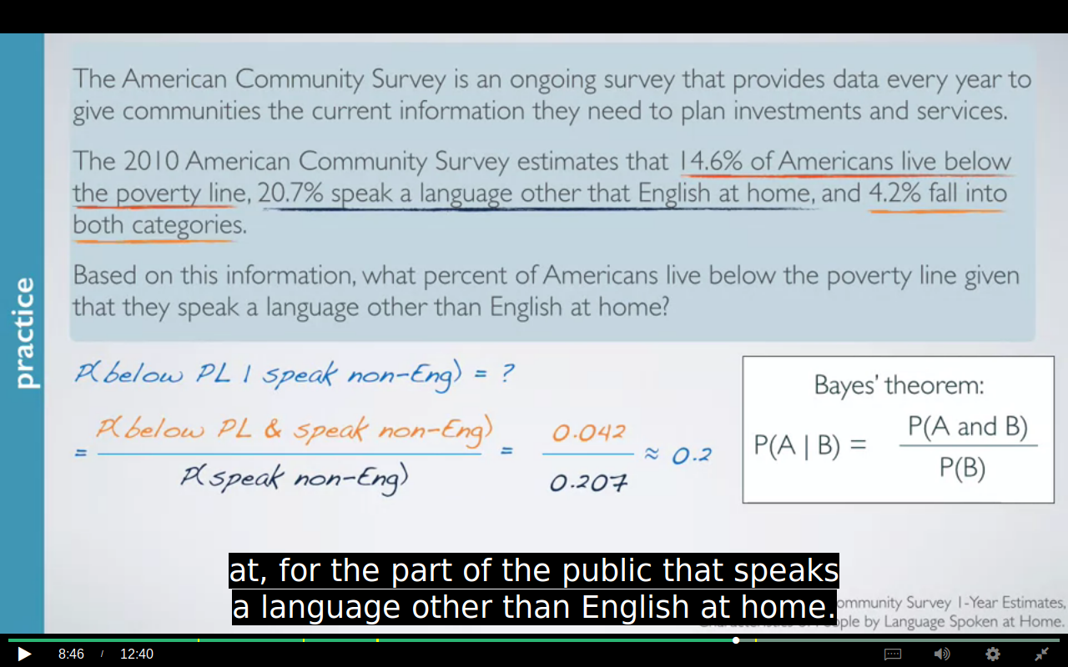
roughly 20% of Americans who speak a language other than English at home also live below the poverty line.
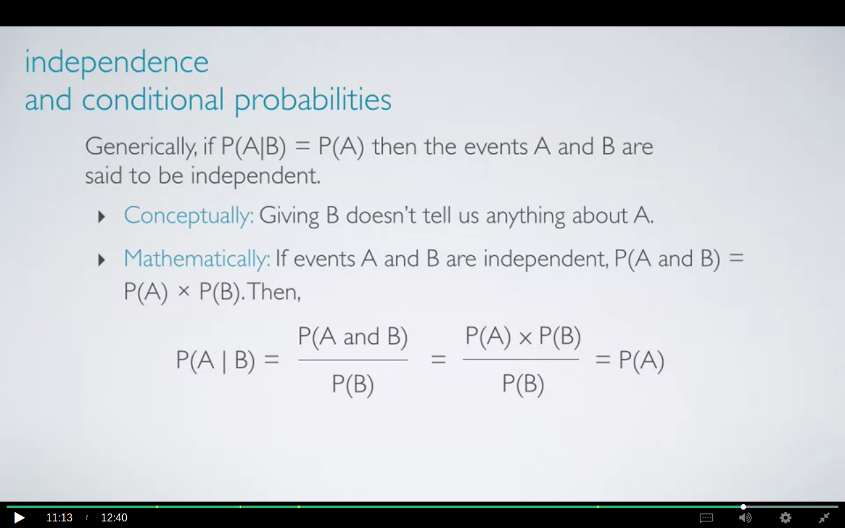

IMPORTANT EXAMPLE:
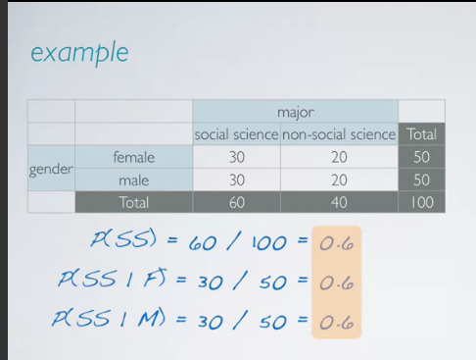
So what we're seeing here is that all of these probabilities are exactly the same. So this goes back to probability of a given b. If that equals probability of a, then we know that the events are independent. In this case, probability of social science equals probability of social science given female or social science given male.So we would determine that the two variables, gender and major are independent of each other, given this hypothetical distribution
PROBABILITY TREES
they are useful when we have to calculate the reverse of what we are given.


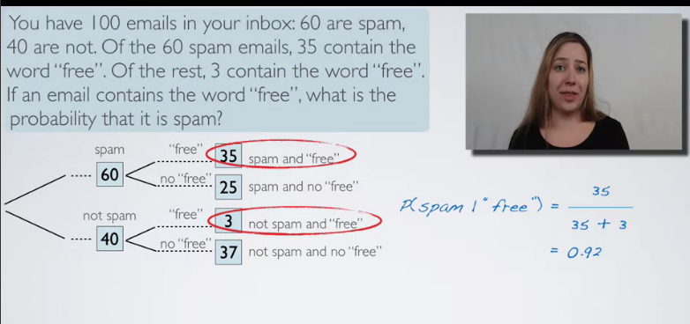
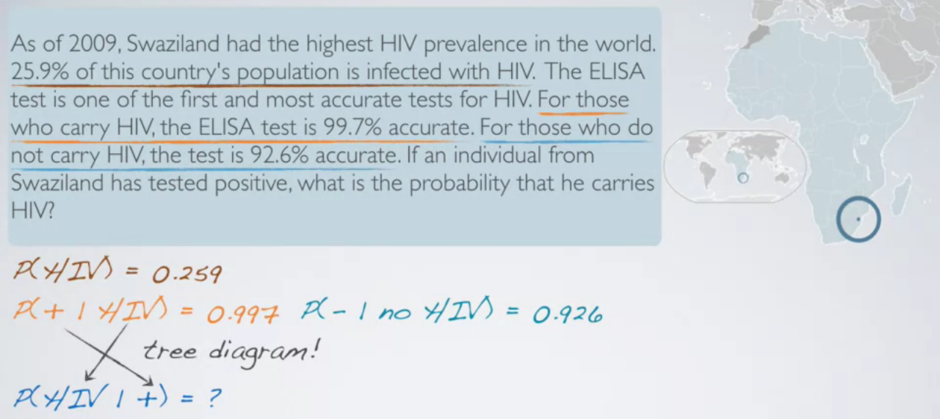
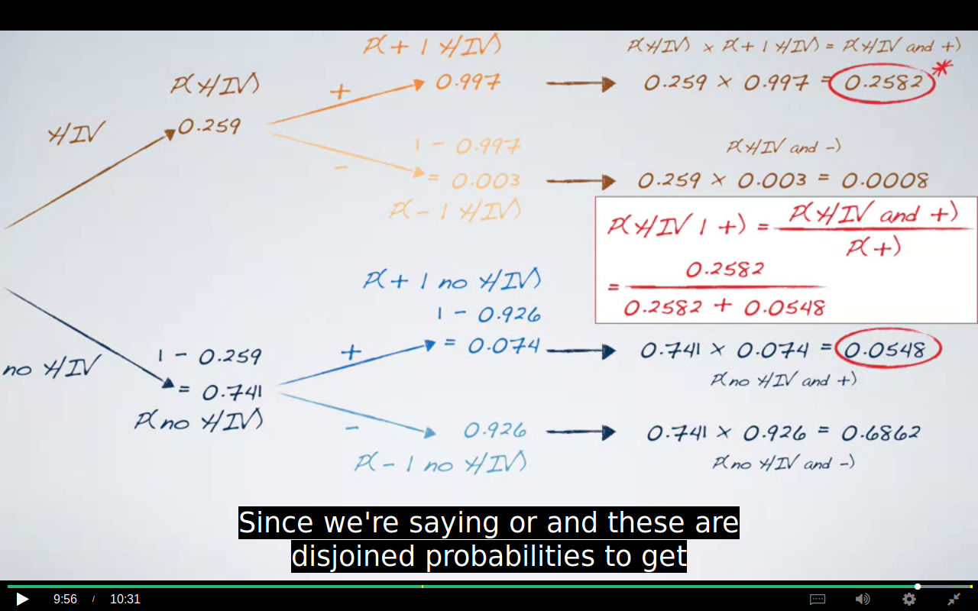
Note that the marginal probability [ P(+) ] is the sum of [P(+ and hiv) + P(+ and no hiv) ].
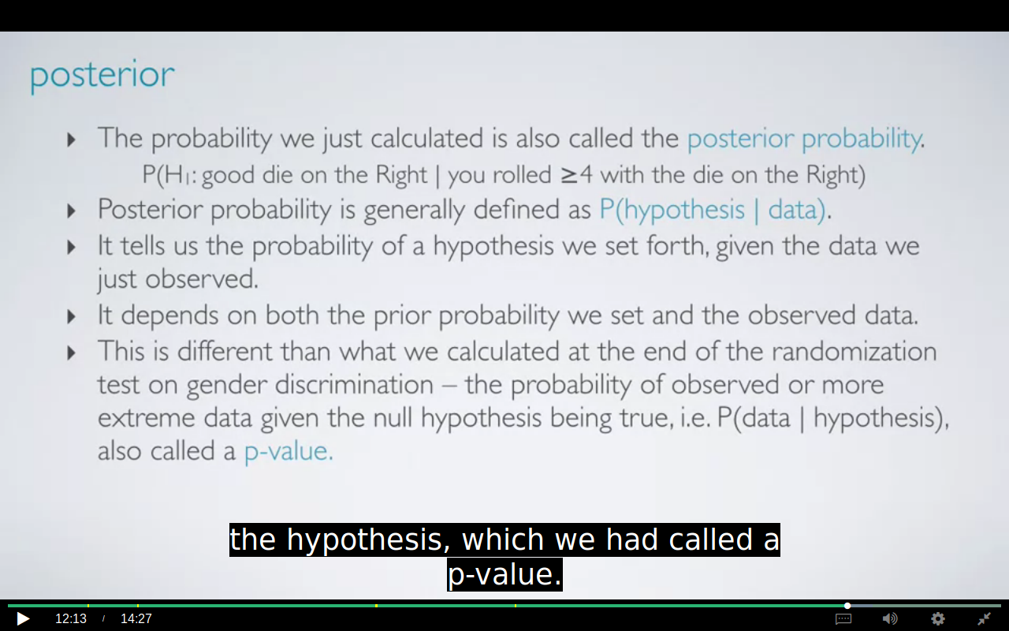
BAYESIAN INFERENCE
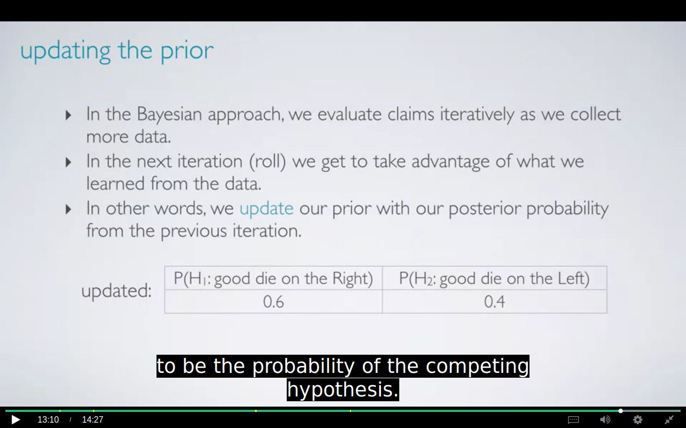
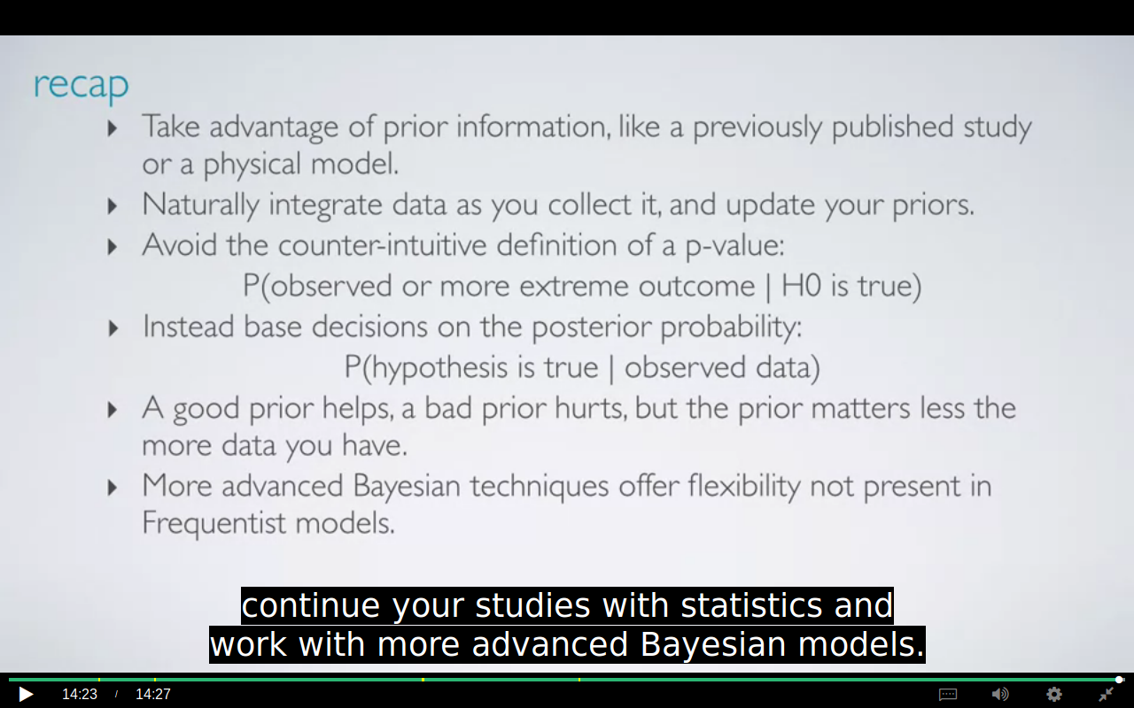
if you didn't have a great prior to begin with, as you collect my, more data, you're going to be able to converge to the right probabilities.

NORMAL DISTRIBUTION
we calculate the STD with min,max and mean.
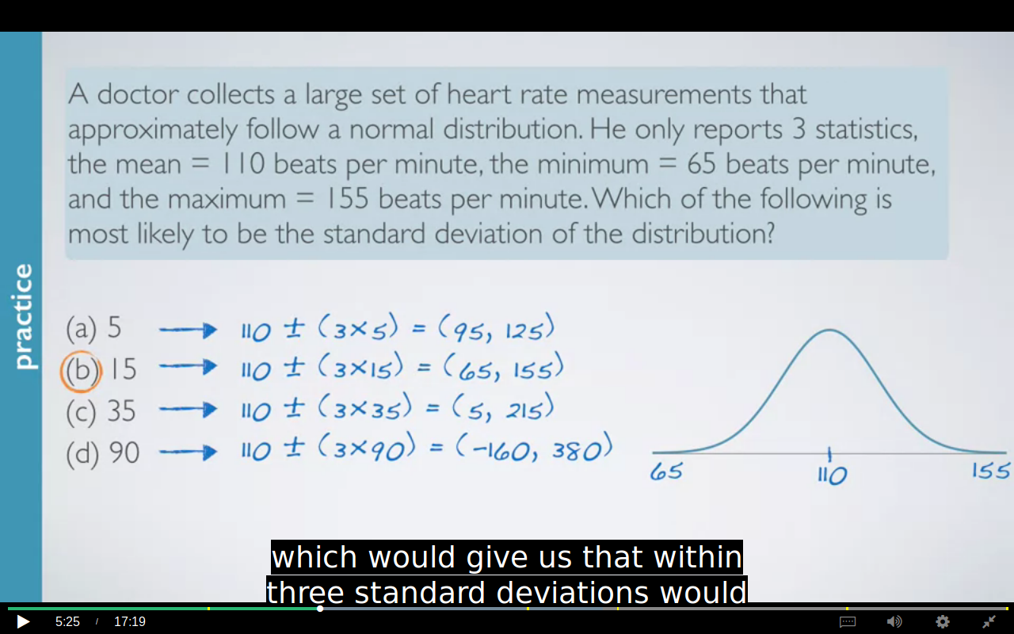
We can calculate Z scores for any distribution.
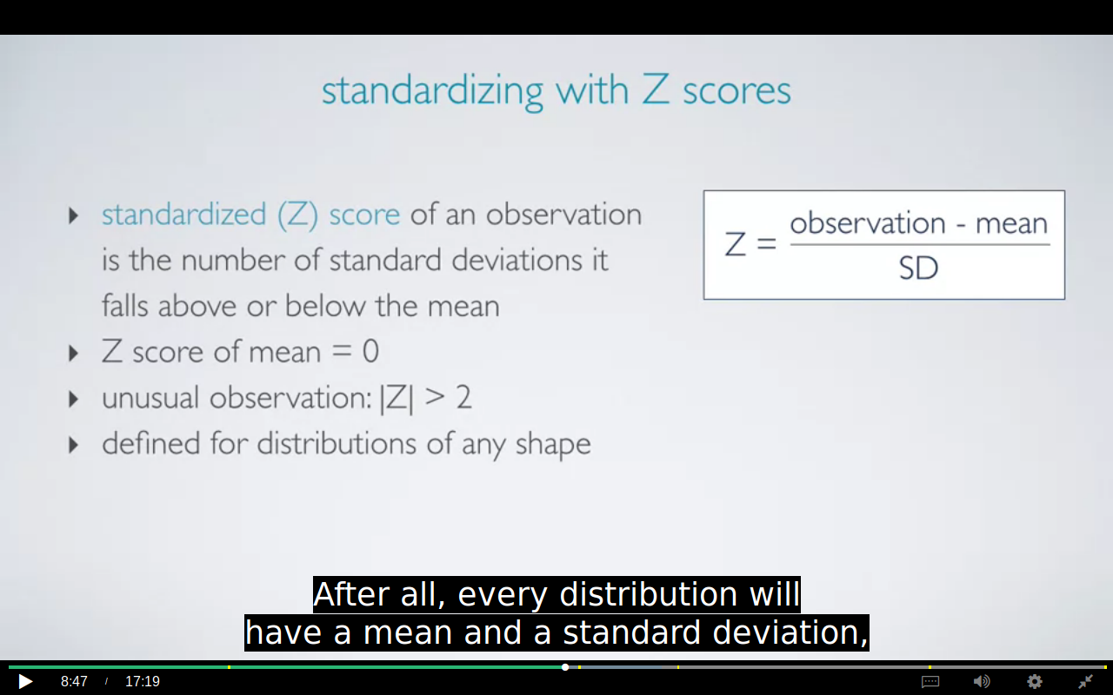
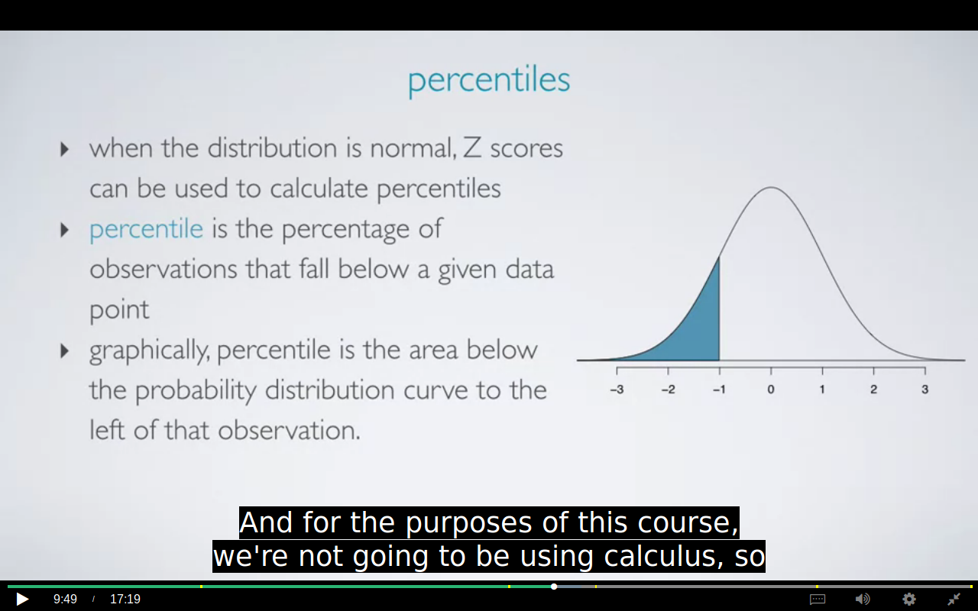
Percentiles can be calculated for dist of any shape but if it is not symmetric then we have to use calculus.

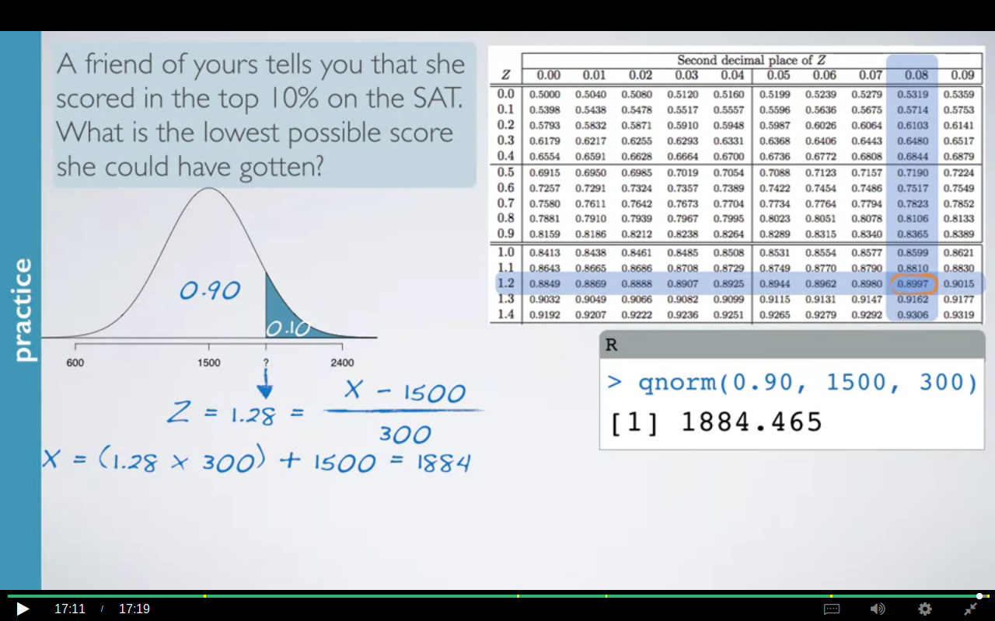

Shape of dist using Normal probability plot.
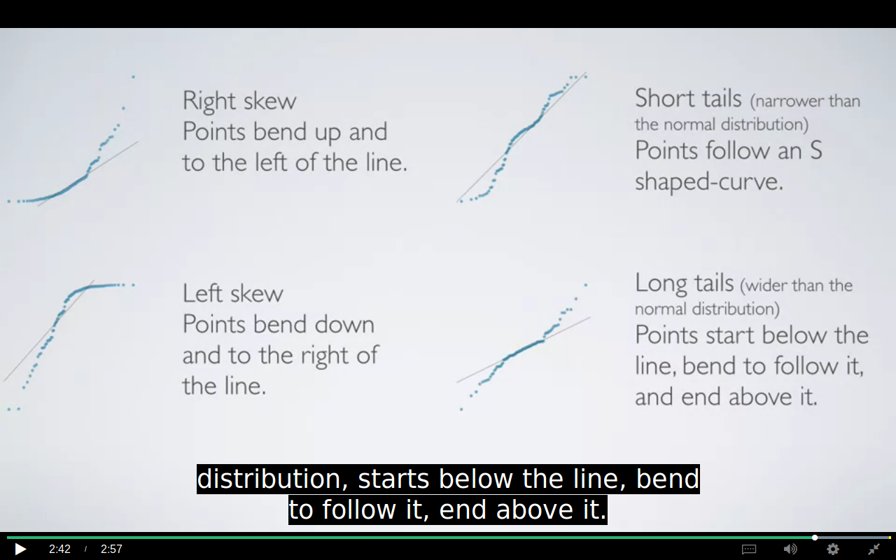
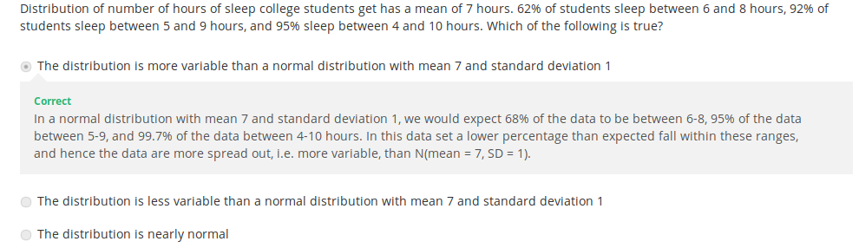
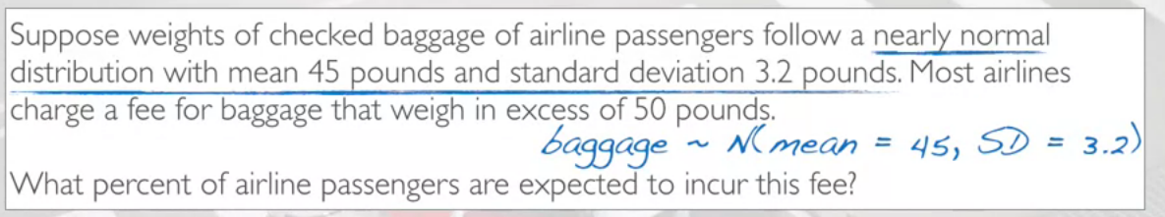
SOLUTION:
> 1-pnorm(50,45,3.2)
[1] 0.05908512

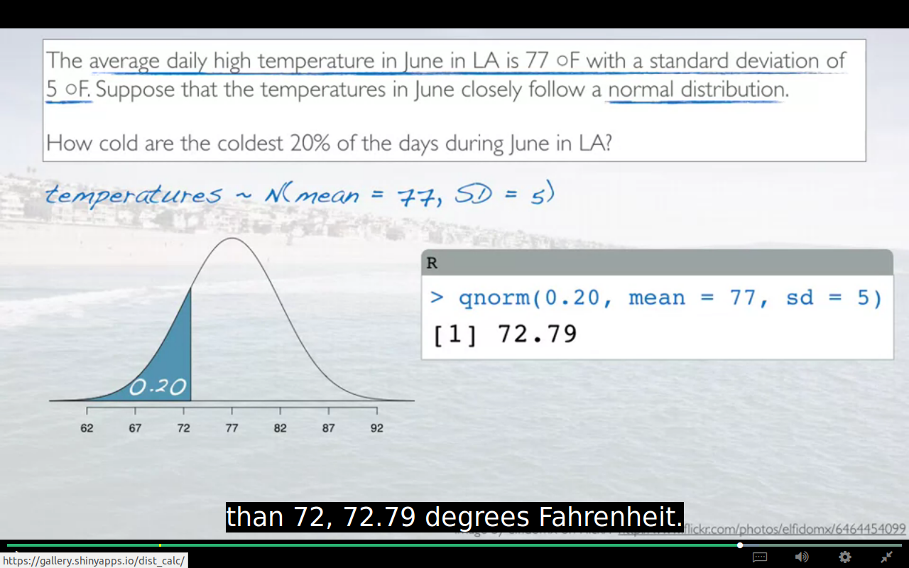
another approach for solving using Z table
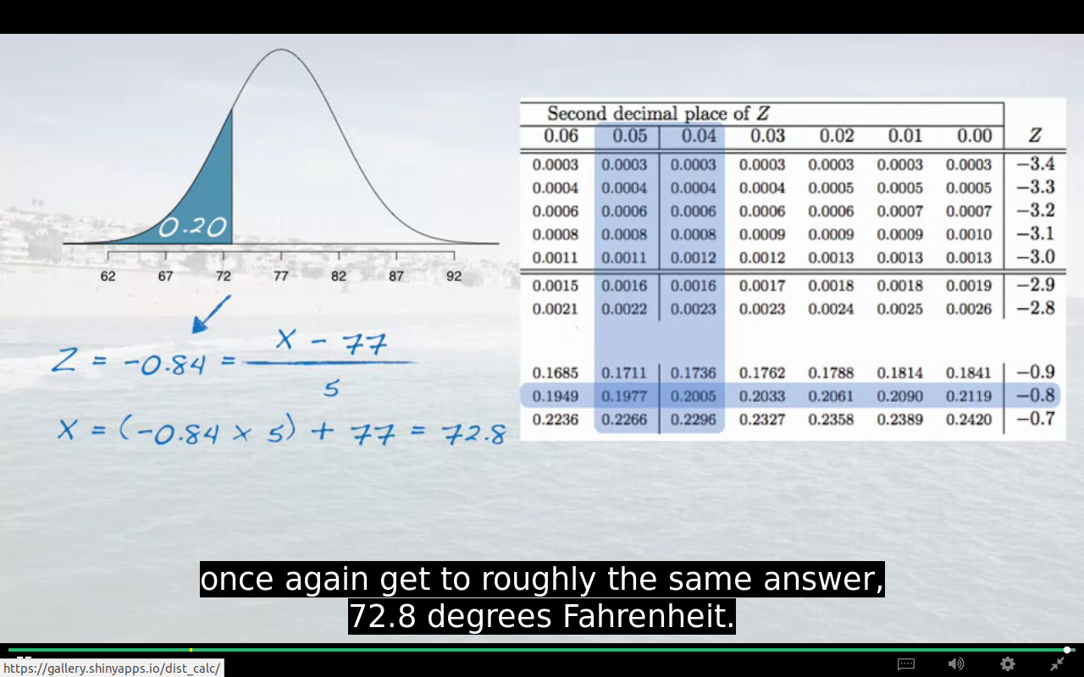
the answer is false bcz in Right skewed distribution the mean is > median.
BINOMIAL DISTRIBUTION
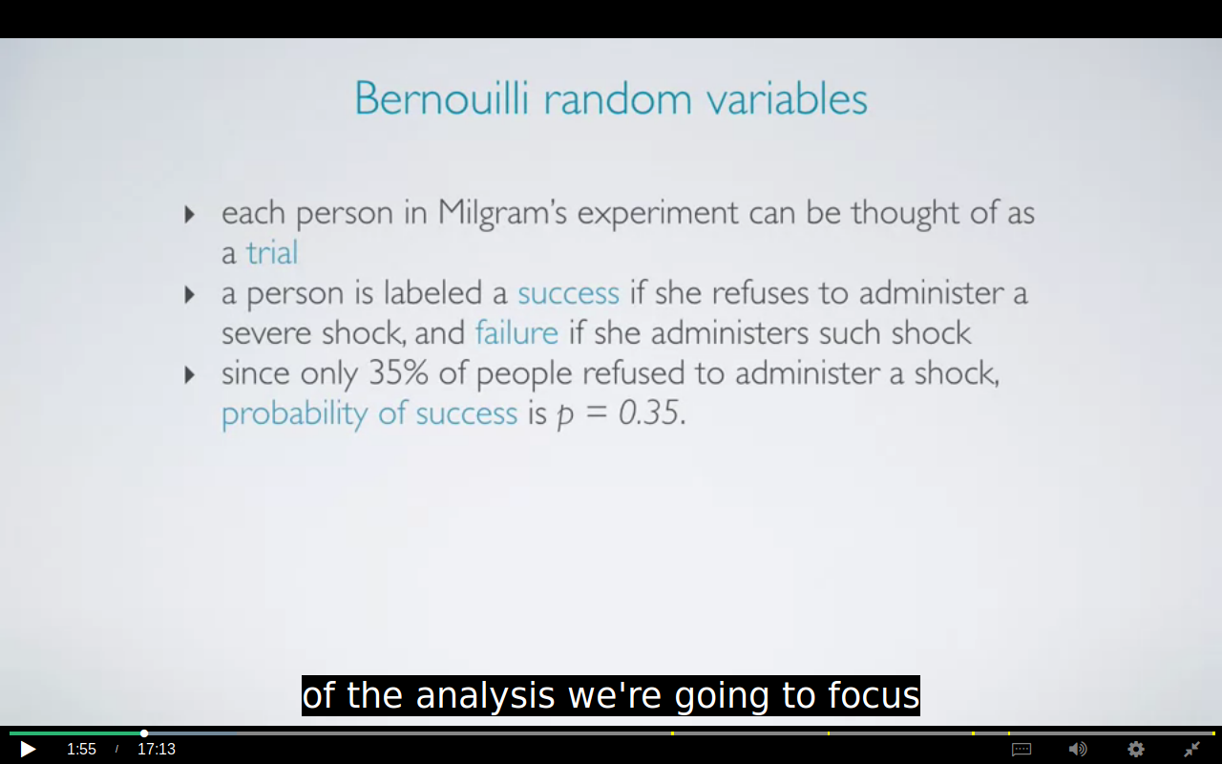
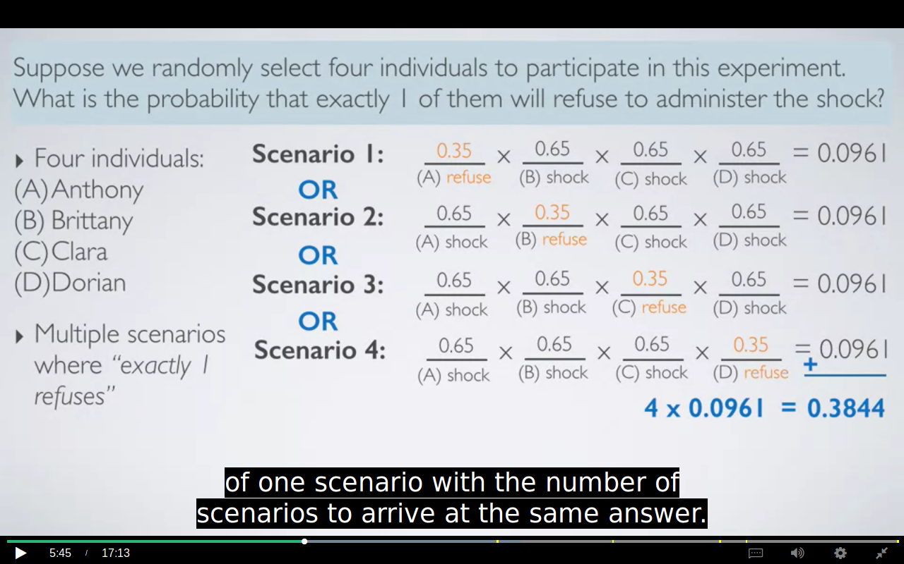

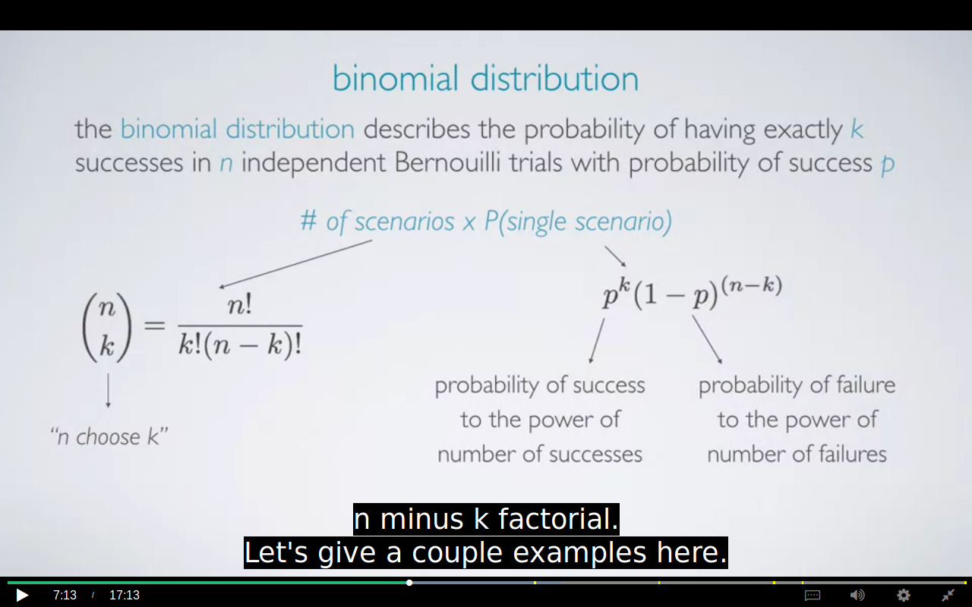
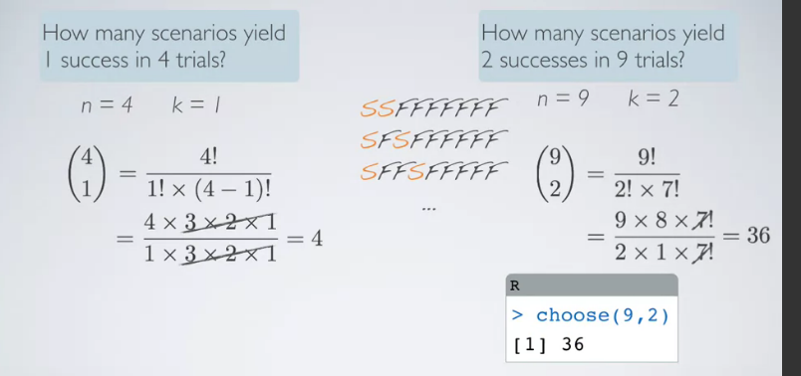

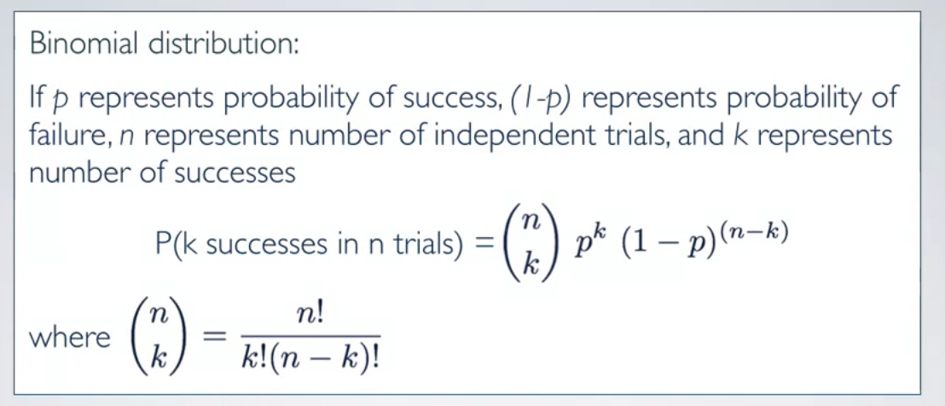

binomial conditions:
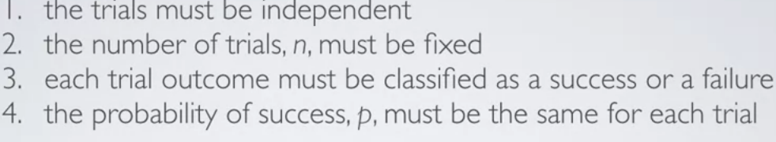

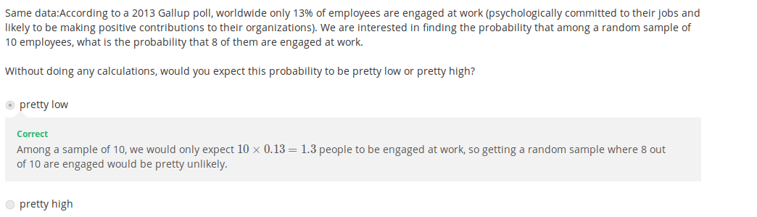

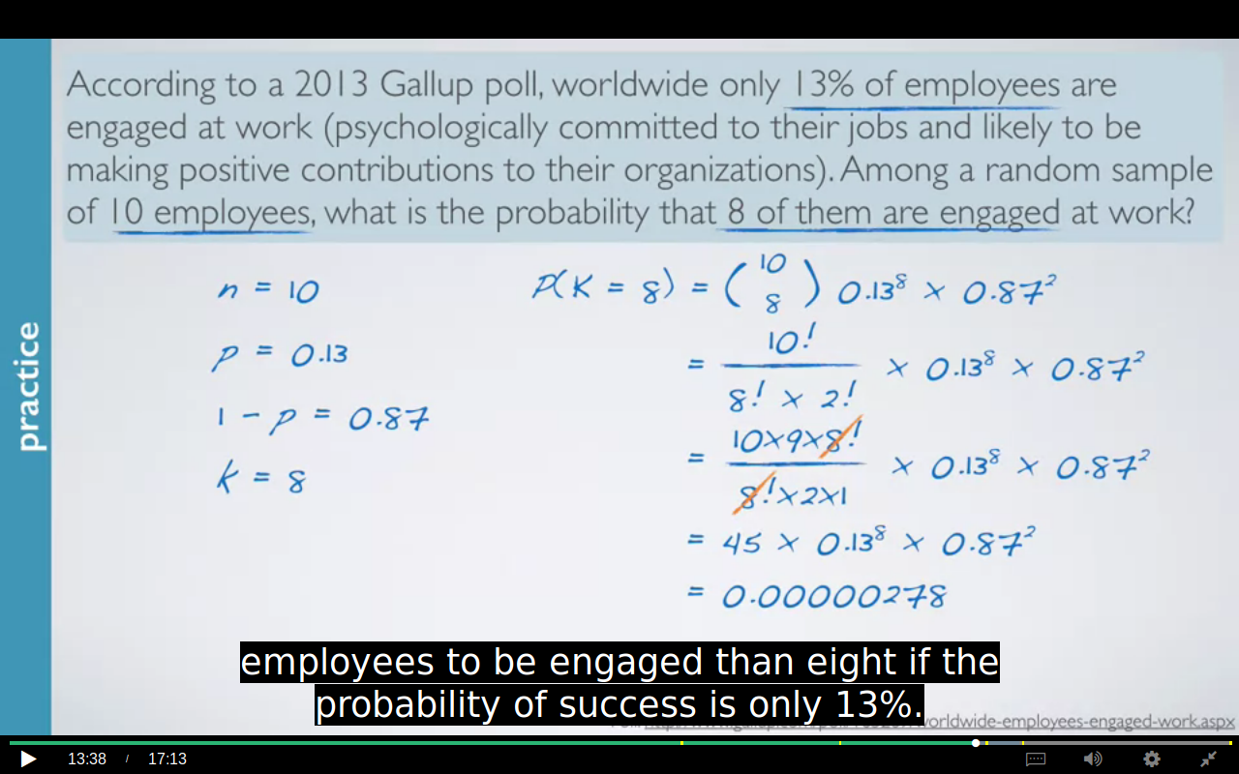
R command:
> choose(10,8) * (0.13^8) * (0.87^2)
[1] 2.77842e-06
> dbinom(8,size=10,p=0.13)
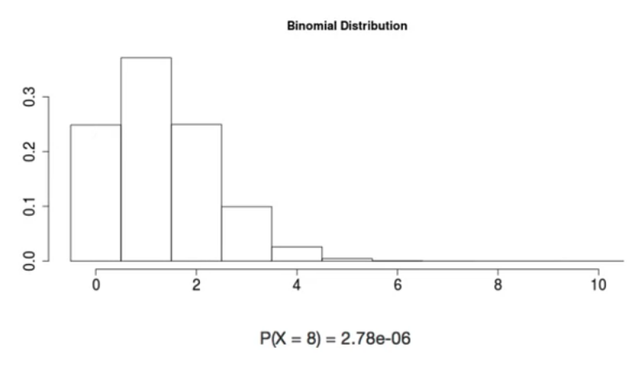
plot for above question using applet.
The probability for 8 is very low therefore there is no bar above it. The height of the bar shows probability.
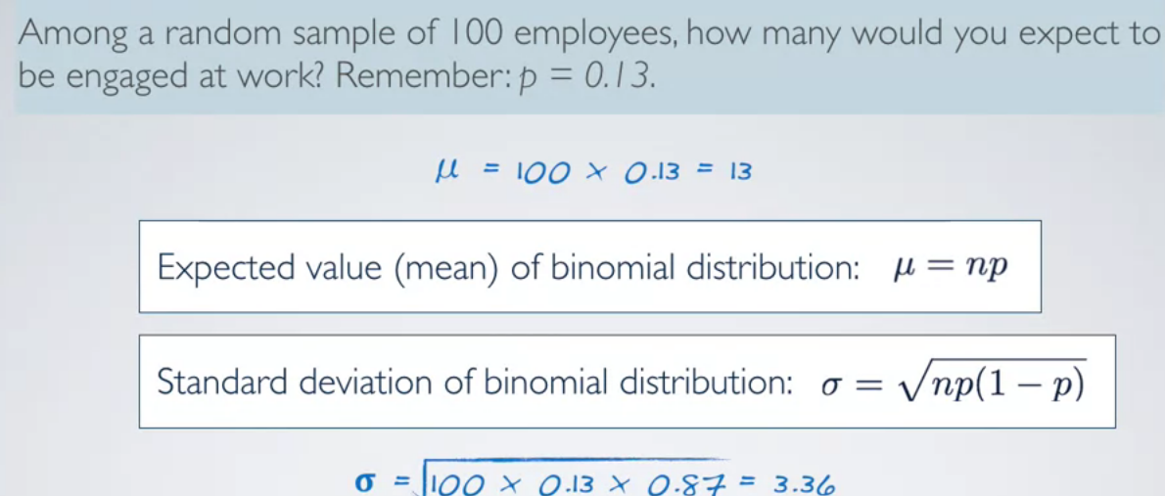

This means that 13 out of 100 employees are expected to be at engaged at work, give or take approximately 3.36. Note that the mean on the standard deviation of a binomial, might not always be whole numbers, and that's alright. These values represent what we would expect to see on average.

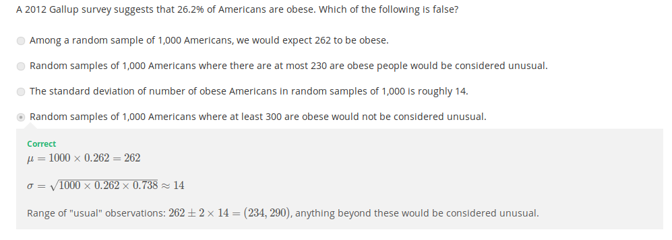
NORMAL APPROXIMATION TO BINOMIAL:
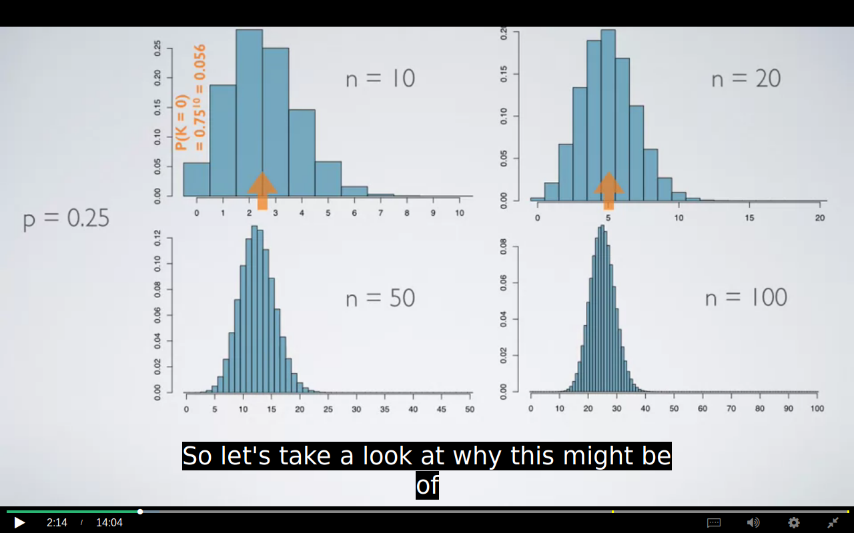
THE CENTER OF THE DISTRIBUTION CHANGES AS WE ARE INCREASING THE NO OF TRIALS.
Calculating the area under the curve is much more simpler then calculating the individual probabilities therefore we use normal approximation

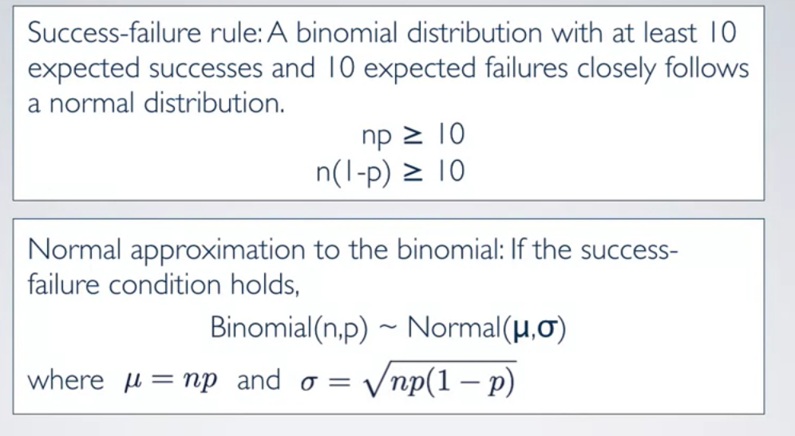
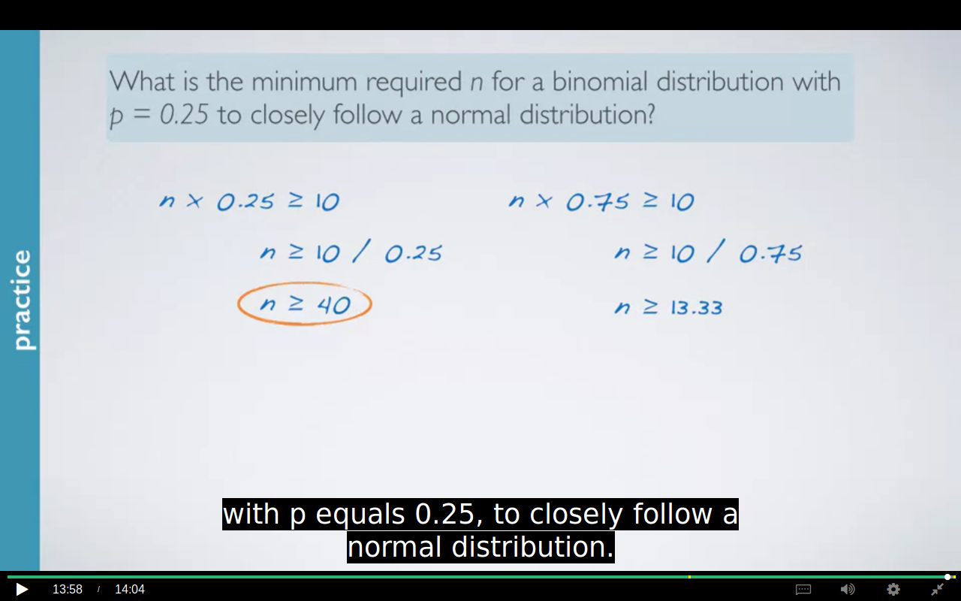

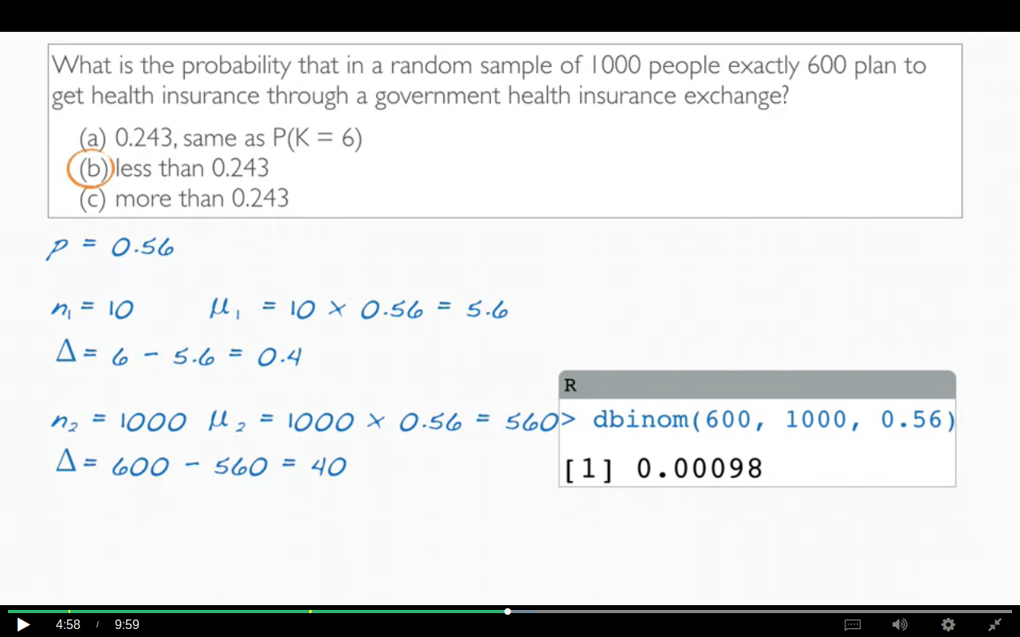
the diff between the expected and desired is much lower in the case of n=10 while it is much larger in n=1000 therefore acc to law of large number the desired outcome is pretty unusual.
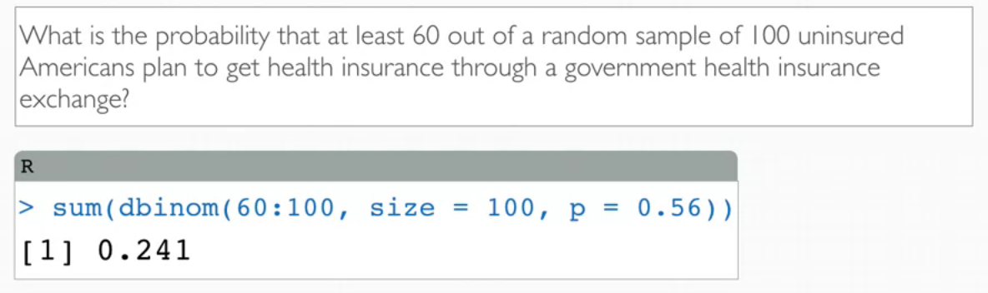
Alternate Solution for same question using 0.5 correction by normal approximation.
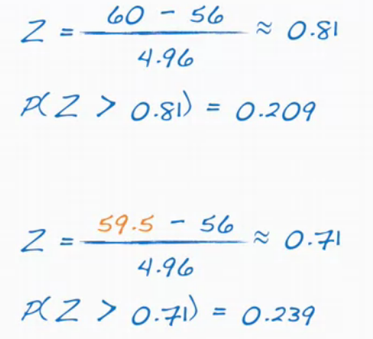
The probability was .20 which differs from the one calculated with the binomial formula.

The probability is almost equal to the binomial after using 0.5 correction.

Important question
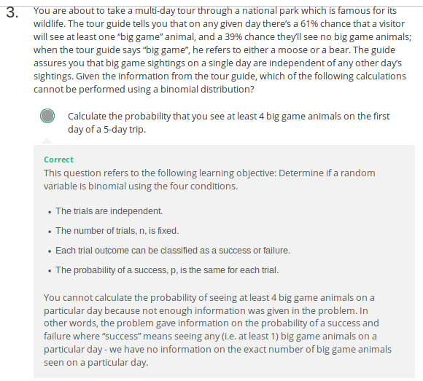
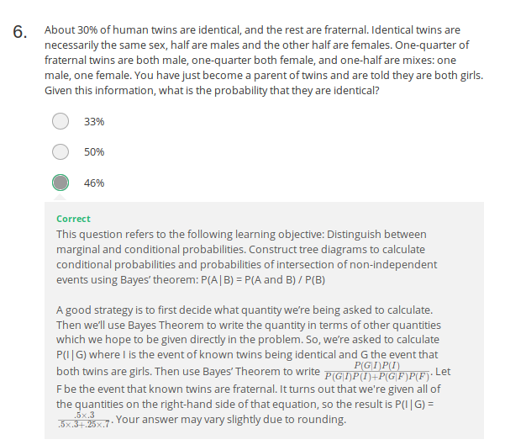

CLT:

INCLUDE THE BELOW WITH CLT TOPIC:

4.5 Hen eggs. The distribution of the number of eggs laid by a certain species of hen during
their breeding period has a mean of 35 eggs with a standard deviation of 18.2. Suppose a group
of researchers randomly samples 45 hens of this species, counts the number of eggs laid during
their breeding period, and records the sample mean. They repeat this 1,000 times, and build a
distribution of sample means.

(a) What is this distribution called?
(b) Would you expect the shape of this distribution to be symmetric, right skewed, or left skewed?
Explain your reasoning.
(c) Calculate the variability of this distribution and state the appropriate term used to refer to
this value.
(d) Suppose the researchers’ budget is reduced and they are only able to collect random samples
of 10 hens. The sample mean of the number of eggs is recorded, and we repeat this 1,000
times, and build a new distribution of sample means. How will the variability of this new
distribution compare to the variability of the original distribution?

ANS 4.5:

(a) We are building a distribution of sam-
ple statistics, in this case the sample mean. Such
a distribution is called a sampling distribution.

(b) Because we are dealing with the distribution
of sample means, we need to check to see if the
Central Limit Theorem applies. Our sample size
is greater than 30, and we are told that random
sampling is employed. With these conditions
met, we expect that the distribution of the sam-
ple mean will be nearly normal and therefore
symmetric.

(c) Because we are dealing with a
sampling distribution, we measure its variability with the standard error. SE = 18.2/ 45 =2.713.

(d) The sample means will be more vari-
able with the smaller sample size.

4.13 Waiting at an ER, Part I. A hospital administrator hoping to improve wait times decides
to estimate the average emergency room waiting time at her hospital. She collects a simple random
sample of 64 patients and determines the time (in minutes) between when they checked in to the
ER until they were first seen by a doctor. A 95% confidence interval based on this sample is (128
minutes, 147 minutes), which is based on the normal model for the mean. Determine whether the
following statements are true or false, and explain your reasoning.
(a) This confidence interval is not valid since we do not know if the population distribution of the
ER wait times is nearly Normal.

(b) We are 95% confident that the average waiting time of these 64 emergency room patients is
between 128 and 147 minutes.

(c) We are 95% confident that the average waiting time of all patients at this hospital’s emergency
room is between 128 and 147 minutes.

(d) 95% of random samples have a sample mean between 128 and 147 minutes.

(e) A 99% confidence interval would be narrower than the 95% confidence interval since we need
to be more sure of our estimate.

(f) The margin of error is 9.5 and the sample mean is 137.5.

(g) In order to decrease the margin of error of a 95% confidence interval to half of what it is now,
we would need to double the sample size.

4.13 (a) False. Provided the data distribution
is not very strongly skewed (n = 64 in this sam-
ple, so we can be slightly lenient with the skew),
the sample mean will be nearly normal, allow-
ing for the method normal approximation de-
scribed.
(b) False. Inference is made on the
population parameter, not the point estimate.
The point estimate is always in the confidence
interval.
(c) True.
(d) False. The confidence
interval is not about a sample mean.
(e) False.To be more confident that we capture the pa-
rameter, we need a wider interval. Think about
needing a bigger net to be more sure of catching
a fish in a murky lake.
(f) True. Optional ex-
planation: This is true since the normal model
was used to model the sample mean. The mar-
gin of error is half the width of the interval, and
the sample mean is the midpoint of the interval.
(g) False. In the calculation of the standard
error, we divide the standard deviation by the
square root of the sample size. To cut the SE
(or margin of error) in half, we would need to
sample 2^2= 4 times the number of people in the
initial sample.

